

KENYAN BASED INVESTMENT RESOURCE APP

GEORGE KIMUNDUI KARANJA

BSCS/2020/45842

This project is Submitted to the Faculty of Information Technology in partial fulfillment of the requirements for the award of a Degree in Bachelor of Science in Computer Science

2024

# DECLARATION

I affirm that the content presented in this work has not been previously presented for consideration or approval in pursuit of any academic degree, either within the confines of this institution or any other accredited university. To the utmost extent of my awareness and conviction, this manuscript does not incorporate any information or materials that have been published or authored by another individual, unless proper acknowledgment and citation have been duly provided.

Students Name: George Kimundui

Student Signature: Sign: ________________________ Date: ________________________

Supervisors’ Name: Mariam Heroe

Supervisors’ Signature Sign: ________________________ Date: ________________________

# ACKNOWLEDGEMENTS

Supreme among all, my gratitude is extended to God for safeguarding me, granting me good health, and endowing me with strength throughout this academic pursuit. My sincere thanks and indebtedness are directed towards my supervisor, Madam Mariam Heroe, for her unwavering support and patient guidance. I express my appreciation to the faculty staff of the Department of Information Communication Technology at Umma University for their invaluable support, both directly and indirectly. Finally, I extend my profound gratitude to my family, friends, and classmates for their unwavering support, meaningful contributions, and uplifting encouragement.

# ABSTRACT

Limited access to financial literacy resources poses a significant barrier to economic participation and individual financial security, particularly in developing nations like Kenya. This project tackles this challenge by creating the "Investment Resource App," a mobile application designed specifically for the Kenyan market. Leveraging the power of Flutter and Firebase technologies, the Investment Resource App provides a user-friendly and dynamic platform fostering collaboration and knowledge exchange within the Kenyan investment community. This commitment to user experience translates into a seamless and intuitive interface, ensuring easy access to valuable resources like educational materials, investment tools, and essential financial information.

The app goes beyond simply providing information. It facilitates seamless communication between investors and essential resources, empowering them to make informed investment decisions. The user-centric design prioritizes clarity and accessibility, ensuring that Kenyans of all financial backgrounds can confidently navigate the app and utilize its functionalities. The development process embraces an iterative methodology, allowing the app to continuously adapt to evolving user needs and technological advancements. This ensures the app remains relevant and at the forefront of innovation within the dynamic Kenyan investment landscape. Through regular updates and ongoing user feedback integration, the Investment Resource App continuously improves its features and functionalities, guaranteeing its long-term value for Kenyan users.

By fostering seamless information exchange and collaboration opportunities, the Investment Resource App transcends being just a platform. It becomes a catalyst for informed decision-making, strategic success, and ultimately, financial inclusion for Kenyans seeking to invest and navigate the complexities of the financial world. With its focus on user-centric design, educational resources, and seamless communication features, the app empowers Kenyans to actively participate in the investment landscape and achieve their financial goals.

Table of Contents

DECLARATION ii

ACKNOWLEDGEMENTS iii

ABSTRACT iv

CHAPTER 1: INTRODUCTION 1

1.1 Background of the study 1

1.2 Problem Statement 1

1.3 Objectives 2

1.3.1 General objectives 2

1.3.2 Specific objectives 2

1.4 Research questions 2

1.5 Scope of the study 2

1.6 The significance of the proposed research is as follows: 3

1.7 Justification 3

1.8 Limitations of the Study 4

CHAPTER 2: LITERATURE REVIEW 5

2.1: Introduction 5

2.2 Evolution of Investing Resources 5

2.3: Description of Current Digital Platforms for Investing Resource Applications 6

2.3.1 InvestmentHub Kenya 6

2.3.2 M-Investa Insights 6

2.3.3 FundSavvy Kenya 7

2.3.4 Naweza Stocks 7

2.4: Gaps in existing technologies 7

2.5: Why is it important to have the proposed system? 7

2.7: Conceptual framework 8

CHAPTER 3: SYSTEM DEVELOPMENT METHODOLOGY 10

3.1 System Development Methodology 10

3.2 The Agile Methodology Life Cycle 10

3.2.1 Planning 11

3.2.2 Analysis 11

3.2.3 Design of the system 11

3.2.4 Coding and Implementation 11

3.2.5 Testing 11

3.2.6 Deployment 11

3.2.7 Maintenance 12

CHAPTER 4: PLANNING 13

4.1 Defining Project Objectives 13

4.2 Gathering, Analysing Requirements & Engaging Stakeholders for Insights 13

4.3 Data Gathering 13

4.3.1 User Surveys 13

4.3.2 Interviews 14

4.3.3 Market Analysis 14

4.4 Constructing a Comprehensive Project Roadmap 14

4.5 Allocating and Managing Resources 14

CHAPTER 5: ANALYSIS 15

5.1 Introduction 15

5.2 Market Analysis and Competitive Landscape 15

5.3 Crafting User Personas 15

5.4 Identifying Use Cases 16

5.5 Defining Functional and Non-Functional Requirements 16

5.6 Creating Wireframes and Prototypes 16

5.7 Documenting and Validating Requirements 17

5.8 Incorporating Feasibility Analysis 17

5.8.1 Financial Viability 17

5.8.2 Technological Viability 17

5.8.3 Psychological Feasibility 18

5.9 Requirements Analysis Phase 18

CHAPTER 6: DESIGN OF THE INVESTMENT RESOURCE APP 19

6.1 Defining Architecture, Modules, and Interfaces 19

6.1.1 Architectural Design 19

6.1.2 Module Design and Responsibilities 19

6.1.3 Interface Design for User Interaction 19

6.2 Visualizing the Investment Resource App 19

6.2.1 Investment Use Case Diagram 19

6.2.2 Investment Data Flow Diagram Level 0 20

6.2.3 Investment Data Flow Diagram Level 1 21

6.2.4 Investment ER Diagram 22

6.2.5 Investment Sequence Diagram 22

6.2.6 Investment Flow Chart 23

6.5 Translating Requirements into Design Elements for Investment Resource App 24

6.5.1 Tailoring User-Centric Interfaces for Kenyan Investors 25

6.5.2 Designing Functional and Non-Functional Elements for Optimal Investment Experience 25

6.6 Validation and Documentation for Investment Resource App 26

6.6.1 Prototyping Investor Experiences 26

6.6.2 Documenting Design Decisions for Investor-Centric Solutions 26

6.6.3 Validation Through Investor Feedback 26

6.7 Conclusion 27

CHAPTER 7: CODING 28

7.1 Introduction 28

7.2 Choosing Flutter Framework for Investment Resource App Development 28

7.3 Development Environment: Android Studio 28

7.4 Leveraging Firebase 28

7.5 System Requirements Specifications 29

7.7 Conclusion 29

CHAPTER 8: TESTING 31

8.1 Introduction 31

8.2 Overview of Testing Methodologies 31

8.3 Methodology of Testing for Investment Resource App 31

8.3.1 Testing of Individual Units 31

8.3.2 System Evaluation 31

8.3.3 Function Evaluation 32

8.4 System Testing and Validation 32

8.5 Test Results and Analysis 34

8.5.1 Classification of Test Results 34

8.5.2 Reporting and Bug Tracking 34

8.6 Importance of Retesting 34

8.7 Conclusion 34

CHAPTER 9: SYSTEM DEPLOYMENT 35

9.1 App Installation Process 35

9.2 System Interfaces 35

9.3 Database Interface 41

9.3.1 Data Storage: Efficient Information Management 41

9.3.2 Data Security: Safeguarding Investment Information 41

9.3.3 User Authentication: Access Control for Investors 42

9.3.4 Data Retrieval and Manipulation: Seamless Investor Interaction 42

9.3.5 Real-time Updates: Keeping Investment Data Current 42

9.4 Database visualization 42

CHAPTER 10: MAINTENANCE 44

10.1 Introduction 44

10.2 Upkeep of the System 44

10.3 Preventative Maintenance 44

10.4 Perfective Upkeep 44

10.5 Adaptive Maintenance 45

10.6 Continuous Improvement 45

10.7 Conclusion 45

CHAPER 11: CONCLUSION, FUTURE WORKS AND RECOMMENDATION 46

11.0 Conclusions 46

11.1 Recommendations 46

11.2 Future Works 46

REFERENCE 48

**LIST OF FIGURES**

Figure 1: The Conceptual Framework 9

Figure 2: Agile Methodology 10

Figure 3: Investment Use Case Diagram 20

Figure 4: Investment Data Flow Diagram Level 0 21

Figure 5: Investment Data Flow Diagram Level 1 21

Figure 6: Investment Resource ER Diagram 22

Figure 7: Investment Sequence Diagram 23

Figure 8: Password Encrypting test 32

Figure 9: Onboarding Screens 36

Figure 10: Sign in, Sign up, Homepages 37

Figure 11: Learning Pages 38

Figure 12: Investment Opportunities 39

Figure 13: Users Profile Page 40

Figure 14: Firebase Encrypted Passwords 41

Figure 15: Firebase Storage Section 42

Figure 16:Firebase Authentications 43

# CHAPTER 1: INTRODUCTION

## 1.1 Background of the study

The financial landscape in Kenya has experienced significant growth and transformation in recent years (Kenya Economic Update (KEU), 2023). This growth is accompanied by a rising interest in financial literacy and investment opportunities among Kenyans. Global trends, according to Collington (2023), highlight technology as a driving force, reshaping the financial sector and introducing new possibilities for investment and wealth management. This transformative momentum is anticipated to persist, creating an environment conducive to innovative financial solutions, as highlighted by the Consultative Group to Assist the Poor (CGAP: Transforming Lives with Financial Inclusion, 2024). Kenya, characterized by a thriving economy and dynamic financial markets, is poised for a noteworthy increase in investment activities. A recent survey by the Capital Markets Authority (Cytonn, 2023) underscores a discernible demand for investment resources tailored to meet the distinct needs of Kenyan investors in this evolving landscape. In response to these dynamic shifts, the proposed study aims to explore the potential of an Android application specifically crafted as an investing resource platform for Kenyan users. Rooted in the belief that empowering Kenyan investors with technology aligned to their financial environment is vital for sustained financial growth, this study seeks to contribute valuable insights to the landscape.

This investing resource app transcends its role as a mere tool; it represents a strategic response to the evolving financial scenario in Kenya. Meticulously curated features and resources are intended to provide Kenyan users with the necessary education and tools to navigate local investment opportunities successfully. To delve deeper into the current financial trends in Kenya, a recent World Bank report (Kenya Economic Update: Accelerating Kenya's Digital Economy, 2019) provides nuanced insights into the economic factors shaping investment decisions. Understanding these factors is crucial for developing an effective investment platform. Additionally, Tiony (2023) explores the role of technology in influencing financial practices in the Kenyan context, shedding light on how technology adoption is shaping investment behavior.

## 1.2 Problem Statement

In Kenya's fast-evolving financial landscape, there's a significant demand for tailored investing resource platforms that meet the unique needs of Kenyan users. Current financial methods might not effectively reach a broader audience, engage users, or provide cost-effective solutions. Regulatory and market dynamics specific to Kenya may not be adequately addressed by existing platforms, limiting the optimal use of available investment resources. The absence of a dedicated investing resource application for the Kenyan market has resulted in a lack of accessible tools, hindering effective financial decision-making. The proposed study aims to address these challenges by exploring the potential of an Android application specifically tailored as an investing resource platform for Kenyan users. Identified problems include limited access to effective financial tools and potential hindrances to well-informed investment decisions due to the absence of localized resources.

Through critical evaluation, the study aims to identify areas for improvement and contribute to the development of more efficient, user-friendly, and impactful investing resource platforms. This research endeavor seeks to bridge the gap between the increasing demand for localized financial resources and the current deficiencies in meeting the evolving needs of Kenyan investors, fostering sustainable financial growth in the region.Top of Form

## 

## 1.3 Objectives

### 1.3.1 General objectives

The primary goal of this research is to assess the effectiveness of a Kenyan investing resource app and pinpoint areas for enhancement, with the overarching aim of developing a more efficient and user-friendly platform. The research is driven by the escalating demand for localized investing resources, acknowledging the need for a platform that can cater to the specific requirements of Kenyan users.

### 1.3.2 Specific objectives

1. To identify user needs for the Kenyan Investment App.
2. To review Existing Technologies and Resources.
3. To design and Develop a Kenyan Investing Resource Application
4. To Test and Validate the Kenyan Investing Resource Application

## 1.4 Research questions

This study explores vital questions to understand the needs of Kenyan investors and inform the development of an effective investing resource application.

1. What do Kenyan investors need from a mobile investment app?
2. What technologies and resources are utilized in global and Kenyan investment management?
3. How to design and develop an effective Kenyan investment resource application?
4. What methods validate the functionality of the Kenyan Investing Resource Application?

## 1.5 Scope of the study

The study aims to explore traditional investment methods prevalent in Kenya, identify current technologies and applications in use, and determine the key features necessary for an effective investing resource application. The scope includes evaluating the performance of the newly developed application in meeting user needs and suggesting enhancements for future iterations. Additionally, the study investigates the cost-effectiveness of the application, especially for business users managing, organizing, and promoting financial activities. Through this scope, the research aims to provide insights for the development of a user-friendly and impactful Kenyan investing resource application.

## 1.6 The significance of the proposed research is as follows:

A study by Kenton (2023) marked a significant stride in the realm of investing resources. It addressed a crucial need for a tailored, informative, and easily accessible platform catering specifically to the demands of Kenyan users. This research, emphasizing the ubiquitous use of mobile applications, delved into the potential advantages of an Android-based investing resource application (Rodrigues et al., 2010). Envisioned as a tool to reach a wider audience, this platform aimed to furnish users with effective tools and insights, thereby facilitating sound financial decision-making (Financial Services - Kenya Investment Authority (KenInvest), 2017). The overarching goal was to empower investors by shedding light on the app's potential as a comprehensive resource, equipping them with the necessary information to make informed decisions and navigate local investment opportunities effectively.

Furthermore, recognizing the pivotal role of financial literacy, a study by Johan et al. (2020) evaluated the app's effectiveness in enhancing users' understanding of investment opportunities, market dynamics, and regulatory intricacies. Ultimately, the research aspired to contribute to the development of more resourceful and user-friendly investing platforms (Motley Fool, 2024). By identifying key features and functionalities that are most beneficial to investors, this comprehensive approach sought to enhance the accessibility and impact of investing resources for Kenyan users, fostering a more informed and empowered investor community.

## 1.7 Justification

The proposed study is pivotal in the dynamic Kenyan financial landscape, addressing the pressing need for a dedicated investing resource app. Tailored to meet the unique requirements of Kenyan investors, this app ensures access to pertinent financial tools aligned with the local financial landscape. Additionally, it leverages the growing prevalence of mobile apps, especially Android, to empower users with accessible and informative tools for effective financial navigation. This contributes significantly to the overall empowerment of individuals in the financial sector. Emphasizing the importance of financial literacy, the study aims to enhance investor understanding of local opportunities, market dynamics, and regulatory nuances.

The study's significance is further underscored by its potential contribution to the development of more resourceful and engaging investing platforms. By identifying key features useful to investors, the research aims to enhance the accessibility and impact of investing resources in line with the evolving needs of the Kenyan financial landscape. In summary, the proposed study emerges as a vital endeavor with far-reaching implications for the empowerment and informed engagement of Kenyan investors.

## 1.8 Limitations of the Study

Primarily, the study's focus on a specific type of financial platform, an Android investing resource app, may introduce constraints on the generalizability of the findings to other financial platforms or diverse mobile operating systems. This specificity could potentially limit the broader applicability of the study's outcomes. Furthermore, the potential reliance on a limited sample size of users may impede the overall representativeness of the findings, affecting the study's ability to capture diverse perspectives within the Kenyan investor community. There is also the possibility of inherent biases, especially if participants are self-selected or recruited through specific channels, which could introduce a source of bias that might impact the validity of the study's conclusions.

The reliance on self-reported data from participants introduces the risk of response bias or social desirability bias, potentially influencing the accuracy and completeness of the information collected. Technical challenges, such as bugs or glitches in the investing resource app, could pose obstacles during data collection and analysis, potentially affecting the robustness of the study's outcomes. Moreover, time and resource constraints may limit the scope and depth of the research, potentially restricting the comprehensiveness of the findings related to the Kenyan investing landscape. Finally, ethical considerations surrounding privacy, data protection, and informed consent was paramount, demanding careful attention to ensure the ethical conduct of the research.

# CHAPTER 2: LITERATURE REVIEW

## 2.1: Introduction

This chapter explores the literature on investing resource applications, analyzing both successful implementations and areas for improvement. It focuses on optimizing processes in the investment landscape, from disseminating information to post-analysis of investment activities. The literature review delves into the global landscape of investing resource applications, examining diverse approaches by countries and organizations. It identifies technological trends within the investment sector and explores the cross-application of investment management techniques in various industries, considering shifts in social, economic, and technological landscapes. Within this exploration, the review scrutinizes platforms providing investing resources, analyzing their impact on financial management. It dissects the role of investment management software and mobile applications, highlighting their contributions to simplifying planning, managing financial activities, and analyzing investment data.

## 2.2 Evolution of Investing Resources

The history of investing resource applications, while not directly tracing back to ancient times, is intertwined with the evolution of financial organization and management. In Kenya, financial practices have undergone a sophisticated transformation, requiring meticulous planning (Kaplan, 2020). While not directly related to mobile applications, historical events offered opportunities for financial exchange and education. Ancient Egypt and Greece held ceremonial events and competitions showcasing financial prowess (Brooks, 2020). The Middle Ages saw financial event management extend to religious celebrations, often organized by the Church. Large-scale financial events like World Fairs emerged in the 19th and early 20th centuries.

The modern era of investing resources, including applications, began in the 20th century. Corporations began employing professional financial planners. Subsequent decades witnessed the rise of financial events like music festivals alongside the growing role of professional financial planning. Technological advancements in the 1980s and 1990s paved the way for online registration and the development of financial applications (Walker, 2018). The global investing resource application industry, catering to Kenyans, encompasses various financial activities including conferences, trade shows, and financial education initiatives. This industry constantly adapts to new technologies, trends, and strategies to meet the evolving needs of Kenyan investors.

## 2.3: Description of Current Digital Platforms for Investing Resource Applications

Digital platforms have revolutionized the landscape of investment resource applications, offering diverse tools for financial planning, management, and decision-making (Agarwal, Khan, & Dey, 2020). These platforms encompass various mediums, including specialized investment apps and online resources tailored for investors of all experience levels (Barber, Huang, & Liu, 2019). Furthermore, a recent study by Fong, Chen, and Zhu (2021), published in the Journal of Investment Technology and Information Management, provides valuable insights into the technological landscape of investment resource applications. This review discusses existing technologies, shedding light on the advancements that have contributed to the digital transformation within the realm of investment tools (Li, Wang, & Luo, 2023).

### 2.3.1 InvestmentHub Kenya

InvestmentHub Kenya emerges as a comprehensive investing resource platform, celebrated for its multifaceted features. A study by Kemboi (2018) highlights the platform's success in providing users with valuable insights into the Kenyan financial market. It offers detailed analyses, investment trends, and personalized financial planning tools. Notably, InvestmentHub Kenya stands out for its user-friendly interface, ensuring accessibility for both novice and seasoned investors (Kemboi, 2018).

The platform's commitment to financial education is evident in its extensive library of resources, covering topics from basic investment principles to advanced market strategies. Users can leverage InvestmentHub Kenya to stay informed about market developments, make informed investment decisions, and cultivate a robust financial portfolio. It's important to acknowledge that while InvestmentHub Kenya offers a wealth of information, users should exercise diligence in cross-referencing data for personalized financial decisions.

### 2.3.2 M-Investa Insights

M-Investa Insights operates as an innovative mobile application dedicated to providing tailored investment insights for Kenyan users. The app distinguishes itself by delivering real-time market updates, personalized investment recommendations, and a user-centric interface. M-Investa Insights empowers investors by offering in-depth analyses of local and global market trends, ensuring users stay informed about potential investment opportunities.

As Saffer (2010) highlights, the app's emphasis on user experience is reflected in its intuitive design. This allows investors to navigate seamlessly through market data, investment news, and personalized portfolio analyses. While M-Investa Insights provides valuable features for investors, users should be mindful of potential subscription costs for accessing premium insights and analytics.

### 2.3.3 FundSavvy Kenya

FundSavvy Kenya emerges as a specialized mobile app designed to assist Kenyan investors in navigating the complexities of mutual funds and investment portfolios. Saffer (2010) highlights the app's user-friendly interface as its primary strength. This interface equips investors with simplified tools for comparing, selecting, and managing mutual funds. FundSavvy Kenya facilitates informed investment decisions by offering comprehensive data on fund performance, risk assessments, and historical trends. Investors can leverage the app to create and monitor personalized investment portfolios aligned with their financial goals. While FundSavvy Kenya offers valuable features for mutual fund investors, users should be aware of potential limitations in coverage, specifically concerning the inclusion of fewer mainstream funds.

### 2.3.4 Naweza Stocks

Naweza Stocks stands as a dedicated investment resource app tailored for Kenyan users seeking insights into the stock market. The app distinguishes itself by providing real-time stock analyses, market news, and personalized stock recommendations. Naweza Stocks serves as an educational tool by offering users a comprehensive understanding of stock market dynamics, enabling them to make informed investment decisions. The app's user interface prioritizes simplicity, ensuring accessibility for users with varying levels of financial expertise. It's essential for users to recognize that while Naweza Stocks offers valuable stock-related information, individual research and consideration of market risks are crucial before making investment decisions.

## 2.4: Gaps in existing technologies

Current investing resource platforms in Kenya, such as InvestmentHub Kenya, M-Investa Insights, FundSavvy Kenya, and Naweza Stocks, offer valuable tools for financial planning and decision-making, as evidenced by online reviews and social media discussions from various app users. However, certain gaps persist in their functionalities, highlighting areas for improvement that the proposed Kenyan Investing Resource Application can address. A study by Njoroge et al. (2022) identifies key limitations in existing platforms, including communication constraints, accessibility limitations, and potential cost barriers.

## 2.5: Why is it important to have the proposed system?

The need for a dedicated investing resource app in the Kenyan context arises from the complexities of financial planning and shortcomings of existing platforms in meeting specific user requirements. Current platforms often lack the depth and features needed by Kenyan investors. The proposed Kenyan Investing Resource App aims to provide a tailored digital platform that not only offers valuable tools for financial planning and decision-making but also bridges the identified gaps comprehensively. According to Akeroyd & Mavugo (2021), the app will strive to revolutionize the financial planning landscape by communication capabilities, allowing users to easily connect with financial advisors or other investors, accessibility making the app user-friendly for all experience levels, and affordability offering a competitive pricing structure or freemium model. This application empowers users to make informed investment decisions, fostering a more engaging, personalized, and accessible experience for all Kenyan investors.

Existing digital platforms for financial planning may not fully cater to the unique needs of Kenyan investors, particularly those with limited internet access or who prefer the convenience of mobile devices. To address this, the proposed solution focuses on a mobile application. While a web-based application could be an option, research by Huang et al. (2018) suggests that reduced mobility compared to mobile apps presents a significant drawback. The convenience and accessibility offered by mobile applications make them the preferred choice for the proposed solution (Wang et al., 2023). This approach also allows the app to tap into existing user bases familiar with mobile platforms. However, some investors might prefer the potential for greater customization and control offered by a web application. Therefore, the proposed solution leans towards a specialized mobile application to ensure optimal user experience and engagement for the majority of Kenyan investors.

## 2.7: Conceptual framework

The current study utilizes the investment decision-making framework proposed by Barber et al. (2019) to inform the development of the Kenyan Investing Resource App. This conceptual framework is designed to cater to both users and administrators. Users, primarily investors, will access the app on their Android devices. They can create profiles and explore a variety of financial tools, investment opportunities, and market insights tailored for the Kenyan context.

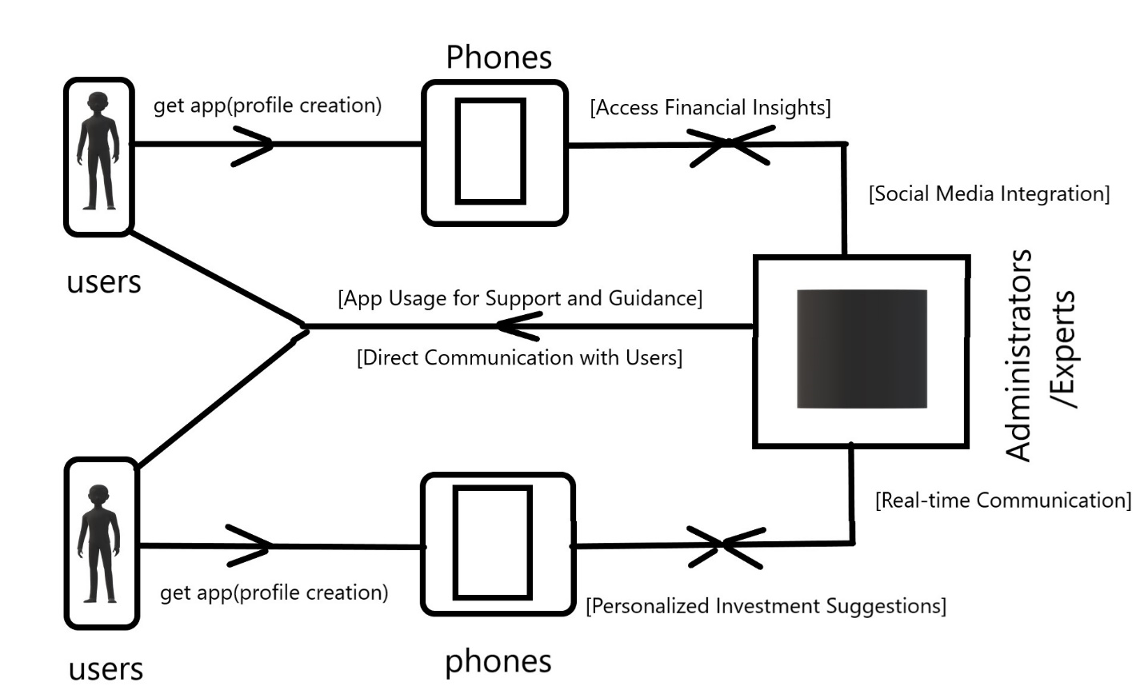

Figure 1: The Conceptual Framework

# CHAPTER 3: SYSTEM DEVELOPMENT METHODOLOGY

## 3.1 System Development Methodology

The development of the Kenyan Investing Resource App utilizes the Agile methodology (Highsmith, 2009) as its guiding approach. This widely adopted software development methodology prioritizes flexibility, collaboration, and incremental delivery of features (Dybå & Dingsøyr, 2008). The adaptable nature of Agile aligns well with the dynamic needs of an investing resource application. The Agile model allows for ongoing changes and updates throughout the development process, a critical benefit for an app designed to navigate the ever-evolving financial landscape (Abrahamsson et al., 2005). This iterative approach involves cycles of planning, execution, and evaluation, ensuring continuous improvement and refinement of the app (Lientz & McLeod, 2010).

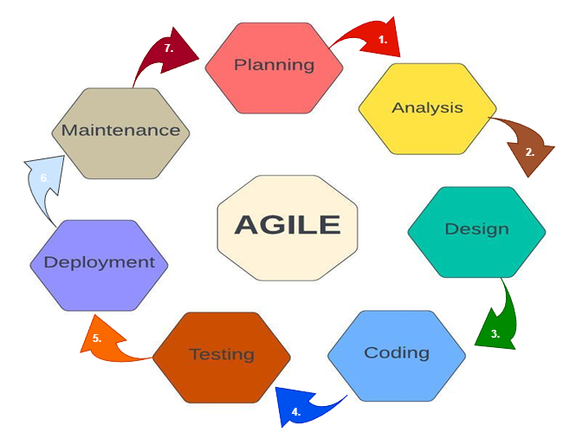

Figure 2: Agile Methodology

## 3.2 The Agile Methodology Life Cycle

The Agile Methodology Life Cycle serves as a structured framework for applying standard business practices to the creation of software applications. Within this cycle, various well-defined phases guide the development process, ensuring a systematic and effective approach to building the Kenyan Investing Resource App.

### 3.2.1 Planning

The planning phase plays a crucial role in outlining the app's scope, defining its objectives, and ensuring its feasibility (Atkinson, Crawford, & Ward, 2006). This stage involves identifying the target users, establishing the budget, specifying app features, selecting key functionalities, and setting up a development timeline. Additionally, the planning phase entails recognizing potential challenges and devising contingency plans to effectively address them.

### 3.2.2 Analysis

The analysis phase encompasses collecting data related to the app's specifications, involving potential users, contributors, financial institutions, and other stakeholders (Basili & Weiss, 1984). This phase is instrumental in pinpointing essential features and functionalities crucial for the investing resource app. Furthermore, the analysis phase includes the development of preliminary prototypes or mock-ups to enhance and clarify the app's requirements.

### 3.2.3 Design of the system

The design phase includes crafting the user interface, system architecture, and database schema (Morbitzer et al., 2001). This design should align with the requirements outlined during the planning and analysis stages. Additionally, the design phase focuses on ensuring the app's capability to manage substantial user traffic and seamlessly integrate with various systems, including payment gateways, email systems, and social media platforms.

### 3.2.4 Coding and Implementation

In the development phase, developers construct the software based on the designs crafted in the earlier phase. The development process prioritizes scalability, security, and efficiency (Fitzgerald et al., 2013). Rigorous testing is an integral part of this phase, ensuring that the software aligns with the specified requirements and is free of bugs.

### 3.2.5 Testing

Perry (2007) discusses various effective methods for software testing. Thorough testing is conducted to identify bugs, assess security vulnerabilities, and evaluate usability Diverse scenarios are considered, including peak load testing to verify the software's capacity to handle anticipated traffic. Additionally, user acceptance testing is performed, enabling real users to assess the software's alignment with their requirements.

### 3.2.6 Deployment

The software is deployed and harmoniously integrated with other systems. This phase includes user training for efficient software utilization and ongoing support to guarantee smooth operations (Delaitre et al., 2015). Rigorous testing in the production environment is undertaken to validate the software's ability to manage actual traffic and seamlessly integrate with other systems.

### 3.2.7 Maintenance

The maintenance phase entails addressing any bugs or issues that emerge after deployment, ensuring optimal performance (Raudvere et al., 2019). Ongoing maintenance includes updating the software to introduce new features and address security vulnerabilities. This phase plays a crucial role in ensuring that the app consistently aligns with the evolving needs of users and maintains its reliability.

# CHAPTER 4: PLANNING

## 4.1 Defining Project Objectives

Developing the Investing Resource App began with a meticulous delineation of the project's objectives and trajectory. This phase guaranteed that each developmental endeavour was in harmony with the app's overarching objectives. In this phase, the objectives of the Investing Resource App project were precisely articulated in quantifiable terms. These objectives encompassed metrics such as user engagement levels and user satisfaction ratings. This clarity served as a navigational beacon for the development process and established a measurable benchmark for success.

## 4.2 Gathering, Analysing Requirements & Engaging Stakeholders for Insights

Gathering, analysing requirements, and engaging stakeholders were crucial steps in understanding the expectations and needs for the Kenyan Investing Resource App. Techniques such as interviews and surveys were employed to gain deep insights from potential users (TechValidate, 2016). The collected data was then meticulously analysed to identify common themes, prioritize features, and ensure seamless alignment with user expectations.

The process also involved participation from key individuals, including potential investors, financial experts, and relevant sponsors. Focused group discussions facilitated direct interaction and fostered an environment conducive to collecting meaningful feedback (Green & Peloza, 2017). This collaborative approach ensured that the app is tailored to meet the specific needs and expectations of its primary stakeholders, including not only users but also those who will contribute to the app's success financially and strategically.

## 4.3 Data Gathering

Utilizing a blend of primary and secondary data collection methods, our research on the Investing Resource App was conducted through a variety of techniques, including:

### 4.3.1 User Surveys

In the quest to understand user preferences and expectations for the Investing Resource App, structured surveys were meticulously designed to gather quantitative data (Saunders, Thornhill, & Lewis, 2016). These surveys, featuring specific questions tailored to user needs, were distributed through diverse channels to ensure a broad range of respondents (Babbie, 2010). The quantitative data gathered through the surveys underwent rigorous analysis, utilizing statistical tools to identify trends and patterns that significantly influenced the prioritization and development of app features. This analysis helped ensure the app addressed the most pressing needs of its target audience.

### 4.3.2 Interviews

To delve deeper into individual user experiences and expectations, one-on-one interviews were conducted with a diverse sample of potential users (Creswell & Creswell, 2018). These interviews provided valuable qualitative insights beyond what structured surveys could capture, allowing users to express their unique perspectives on investment resource needs. Interview responses were meticulously recorded and analysed, extracting recurring themes, concerns, and suggestions that played a pivotal role in shaping the app development process (Elo & Kyngäs, 2008). This in-depth analysis ensured the app addressed not only common needs but also catered to the specific experiences and challenges faced by various user groups.

### 4.3.3 Market Analysis

The findings from this market analysis provided valuable insights into successful features offered by competitors, existing market gaps that the Kenyan Investing Resource App can address, and potential areas for innovation that can differentiate the app within the market. A comprehensive investigation into the broader industry landscape was conducted to understand the Kenyan Investing Resource App's position within the market (Porter, 2008). This involved a thorough review of competitor apps, industry reports, and user feedback on similar platforms.

## 4.4 Constructing a Comprehensive Project Roadmap

Crafting a comprehensive project roadmap for the Investing Resource App involved breaking down development into key phases, tasks, and milestones. Each phase addressed critical aspects like design, coding, testing, and deployment. Milestones signified significant achievements, while identifying and strategizing for potential risks ensured a resilient development process. This roadmap guided the team through a streamlined development journey, marking progress and ensuring successful app delivery.

## 4.5 Allocating and Managing Resources

Resource allocation entailed identifying the financial, human, and technological resources essential for project success. Strategic resource allocation ensured optimal utilization, aligning with the project's goals. Efficient resource management involved continuous oversight, monitoring project progress, and making necessary adjustments. This approach guaranteed a well-balanced allocation that supported the app's development and enhanced overall project efficiency.

# CHAPTER 5: ANALYSIS

## 5.1 Introduction

This chapter provides a detailed outline of the key activities conducted during the analysis phase of the project. These activities aimed to refine the understanding of user needs and project requirements established in the planning phase. Here's a breakdown of the key analysis activities:

* User Requirements Analysis: Data gathered during the planning phase, surveys, interviews, stakeholder discussions, provided a strong foundation for understanding user needs. This analysis phase further refined that understanding by:
* Identifying User Personas: Detailed profiles of target users were created, including demographics, financial literacy levels, investment goals, and preferred communication channels (Cooper, 2014). These personas helped the development team empathize with users and design features tailored to their specific needs. For example, a user persona might represent a young professional with limited investment experience who seeks guidance on building a portfolio.
* Developing Use Cases: Specific user interactions with the app were mapped out. This involved detailing user actions (e.g., registering, searching for investments) and anticipated system responses (e.g., successful registration, displaying relevant investment options). A study by Bruegge & Dustin (2016) showed that use cases provide valuable insights for designing user flows and functionalities. For instance, a use case might describe the steps involved in a user setting up a personalized investment plan within the app.

# 5.2 Market Analysis and Competitive Landscape

Building upon the market research conducted in Chapter 4, this phase conducted a deeper dive into the competitive landscape: Competitor analysis: Existing investment resource applications in Kenya and beyond were evaluated using a SWOT (Strengths, Weaknesses, Opportunities, Threats) analysis to identify gaps and opportunities for differentiation (Grant, 2020).Market trends: An analysis of current trends in the Kenyan investment market was conducted, such as the growing adoption of mobile financial services, to ensure the app catered to evolving user needs (World Bank, 2023).

## 5.3 Crafting User Personas

The development team actively crafts user personas to gain a deeper understanding of their target audience (Cooper, 2014). These user personas are fictional characters that represent diverse user profiles. Each persona includes details such as demographics, financial literacy levels, investment goals, and preferred communication channels.

# 5.4 Identifying Use Cases

Use cases play a crucial role in detailing how users will interact with the Kenyan Investing Resource App. These scenarios outline specific user actions and anticipated system responses, providing a comprehensive roadmap for user flows within the app (Bruegge & Dustin, 2016). Understanding User Journeys: By identifying and documenting use cases, the development team gains valuable insights into the steps users take to achieve their goals within the app. For example, a use case might detail the process a user goes through to research and invest in a specific stock. Guiding User Experience (UX) and Functionality: These insights gained from use cases guide the development of the app's user experience and overall functionality. By considering different use cases, the team can ensure the app is intuitive and allows users to complete their investment goals seamlessly (Rosenbaum et al., 2020).

## 5.5 Defining Functional and Non-Functional Requirements

The application catered for both user needs and technical excellence. The Kenyan Investing Resource App achieves this balance through well-defined functional and non-functional requirements:

Functional Requirements: These requirements outline the app's intended features and functionalities, ensuring alignment with user expectations (Iivari, 2007). For example, functional requirements might specify features like the ability to learn about investment opportunities, search for specific investments, or conduct secure login processes.

Non-Functional Requirements: While functional requirements define what the app does, non-functional requirements encompass aspects such as performance, security, and usability (Pressman & Maxim, 2015). These requirements establish standards for technical excellence. For instance, non-functional requirements might specify performance benchmarks for how quickly the app loads information, or security protocols to safeguard user data.

This dual approach of considering both functional and non-functional requirements guarantees that the Kenyan Investing Resource App delivers a reliable and user-friendly platform for informed investment decisions (Carlson & Burnett, 2001). By meeting user needs for features and functionalities while also adhering to technical standards for performance, security, and usability, the app can empower users to make informed investment decisions with confidence.

## 5.6 Creating Wireframes and Prototypes

Wireframes and prototypes are essential visual aids used in the early design stages of the Kenyan Investing Resource App to refine the user interface and user experience (UX).

* **Wireframes:** These static blueprints emphasize the layout and structure of the app's interface (Wright & Rudd, 2010). For example, a wireframe might show the placement of investment options on a screen or the organization of navigation menus. Wireframes help stakeholders visualize the overall structure of the app and identify potential usability issues early in the design process.
* **Prototypes:** While wireframes provide a basic layout, prototypes offer a more interactive experience (Mueller & Xiao, 2014). These interactive mock-ups simulate user interactions with the app, allowing users to click on buttons, navigate through screens, and experience how the app would function in practice. For instance, a prototype might allow users to click on an investment symbol to view detailed information. Prototypes are valuable tools for gathering user feedback and iterating on the design to improve the overall UX.

## 5.7 Documenting and Validating Requirements

Thorough documentation of requirements is crucial for the Kenyan Investing Resource App's development team. This documentation process involves capturing functional features, what the app should do, non-functional specifications, how the app should perform, and user stories, how users will interact with the app (Cysneiros & Leite, 2004). Following the initial documentation, a validation step is essential. This involves confirming that the documented requirements accurately capture user needs. This validation process helps prevent misunderstandings and ensures the requirements effectively guide subsequent design and development stages (Aurum & Wohlin, 2005). This collaborative approach, where requirements are documented and validated, ensures that the final app meets the needs of all stakeholders, including users, investors, and developers.

## 5.8 Incorporating Feasibility Analysis

Prior to initiating development of the Kenyan Investing Resource App, a thorough feasibility analysis is imperative. This assessment served as a critical foundation for the project's success by evaluating various factors and ensuring alignment with organizational goals (Sommerville, 2016). A well-defined feasibility analysis typically explored three key areas:

### 5.8.1 Financial Viability

Within the context of investment resource applications, financial feasibility holds paramount importance. A thorough cost-benefit analysis is a crucial step in assessing the app's financial viability (Project Management Institute, 2021). This analysis weighs the anticipated benefits of the app against the associated expenses.

### 5.8.2 Technological Viability

Ensured technical feasibility was critical for the Kenyan Investing Resource App's success. This involved assessing several key factors to guarantee a robust and seamless user experience (Pfleeger & Pfleeger, 2019). Here's a breakdown of these factors:

* Hardware and Software Capabilities: This assessment evaluated whether existing hardware and software resources were sufficient to develop and run the app effectively. Consideration was given to factors like processing power, storage capacity, and compatibility with various operating systems.
* Integration Potential: The app's potential to integrate with existing financial systems was crucial. This ensured users could access and manage their investments seamlessly within the app.
* Security Standards Compliance: Adherence to rigorous financial and data security standards was paramount. This protected sensitive user information and built trust with users.

### 5.8.3 Psychological Feasibility

Ensuring user acceptance was paramount, and achieving this hinged on the app's psychological feasibility (Rogers, 2020). A thorough evaluation explored the app's impact on user interactions, user-friendliness for diverse user profiles (e.g., beginners versus experienced investors), and overall usability for both tech-savvy and those with less technical background. This focus on a user-centric approach ensured the app was intuitive and easy to learn and navigate, fostering user confidence and ultimately building a loyal user base.

## 5.9 Requirements Analysis Phase

The requirements analysis phase concludes with a comprehensive understanding of user needs, well-documented use cases, clearly defined functionalities, and validated requirements. This lays a solid foundation for subsequent design and development stages, providing a roadmap that is both user-centric and aligned with the goals of the Investment Resource App.

# CHAPTER 6: DESIGN OF THE INVESTMENT RESOURCE APP

## 6.1 Defining Architecture, Modules, and Interfaces

The design phase of the Investing Resource App marks a pivotal step in translating user requirements into a tangible and user-friendly software solution. This section delves into the complexities of system design, meticulously crafted to ensure the app's effectiveness, usability, and alignment with user expectations. In the system design phase of the Investing Resource App, the architecture, modules, and interfaces were meticulously defined to create a coherent and functional system. This involved establishing how different components would interact, ensuring seamless communication between modules.

### 6.1.1 Architectural Design

The architecture of the Kenyan Investing Resource App was carefully designed to prioritize scalability, reliability, and performance (Bass, Clements, & Kazman, 2012). Following established architectural principles, the development team selected an architectural pattern that best suited the app's specific requirements. Common patterns like client-server or microservices were considered, with the focus being on enabling efficient data flow between users and the app's backend systems.

### 6.1.2 Module Design and Responsibilities

Each module within the Investing Resource App was assigned specific responsibilities and functionalities. Modules, such as resource analysis and user profile management, were distinctly defined to ensure clarity and efficient development. This modular approach facilitates the independent development, testing, and maintenance of individual app components, contributing to the overall robustness and scalability of the Investment Resource App.

### 6.1.3 Interface Design for User Interaction

The interface design for the Investment Resource App has been meticulously crafted to cater to the unique needs and preferences of Kenyan investors, ensuring a seamless and user-friendly experience. The primary focus has been on aligning the interfaces with the diverse user personas identified during the analysis phase, as well as addressing specific use cases relevant to the Kenyan investment landscape.

## 6.2 Visualizing the Investment Resource App

Visual representations, such as diagrams, play a pivotal role in providing a comprehensive overview of the Investment Resource App's functionalities, user interactions, and data flow. These visual tools not only aid in understanding but also facilitate effective communication and refinement of the app's design to cater specifically to the needs of Kenyan investors.

### 6.2.1 Investment Use Case Diagram

The Investment Resource App's use case diagram served as a visual representation of the interactions between different actors within the app's ecosystem (Cockburn, 2005). This diagram clearly outlined the essential functionalities and user flows of the app. By focusing on the roles of Investors and Administrators, the diagram effectively communicated how these actors would interact with the app and the types of actions they could perform.

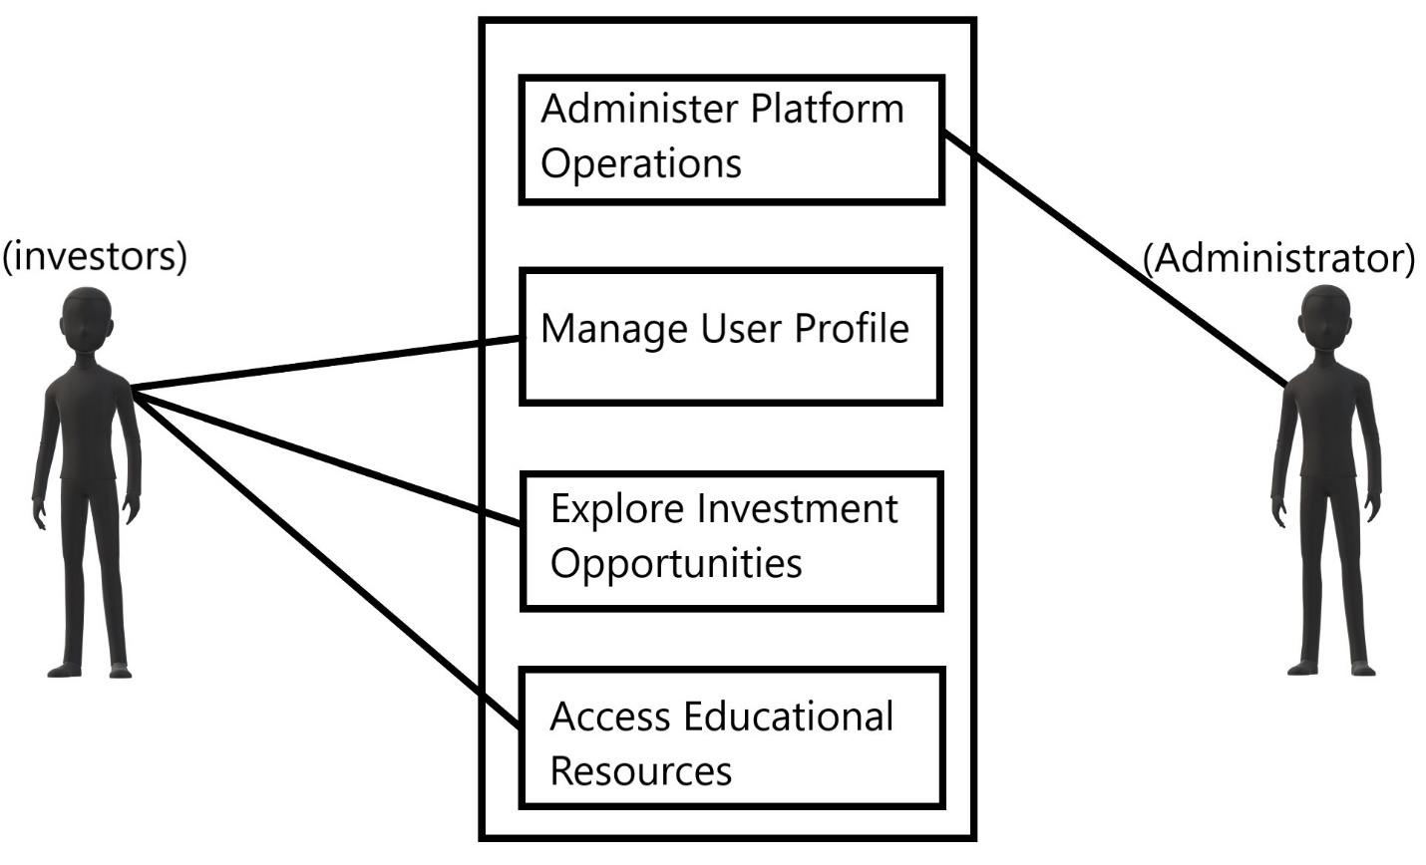

Figure 3: Investment Use Case Diagram

The use case diagram delineates how each actor contributes to the app's functionality, guiding the design and development processes with a keen focus on the specific needs and expectations of Kenyan investors.

### 6.2.2 Investment Data Flow Diagram Level 0

The Data Flow Diagram (DFD) Level 0 for the Investment Resource App presents an overview of the high-level data flow within the proposed application. It illustrates how data moves between external entities, processes, and data stores, showcasing the main interactions that facilitate the functioning of the app within the Kenyan investment landscape.

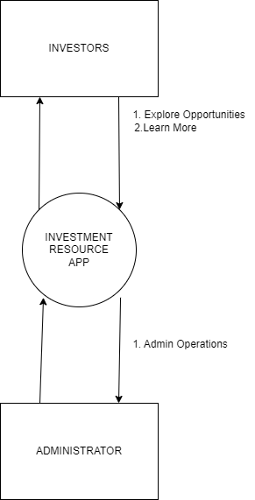

Figure 4: Investment Data Flow Diagram Level 0

### 6.2.3 Investment Data Flow Diagram Level 1

The Data Flow Diagram (DFD) Level 1 provides a detailed depiction of the data flow within the Investment Resource App. This diagram breaks down the processes identified in the Level 0 diagram, showcasing the interactions and data exchanges between them. It delves deeper into the app's functionality, providing a clearer understanding of how specific tasks and operations are carried out and how data is utilized at different stages of the app's operation.

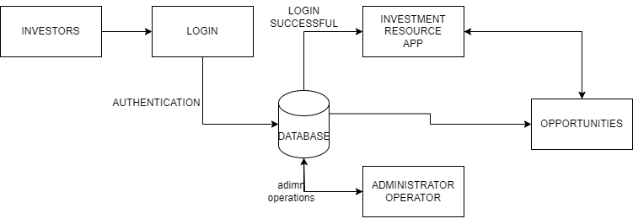

Figure 5: Investment Data Flow Diagram Level 1

### 6.2.4 Investment ER Diagram

The Entity-Relationship (ER) diagram for the Investment Resource App offered a visual representation of entities, attributes, and relationships. It depicts how different entities, such as "Investor," "Administrator," "Investment Opportunity," "Portfolio," and others, are related to each other within the Kenyan investment context.

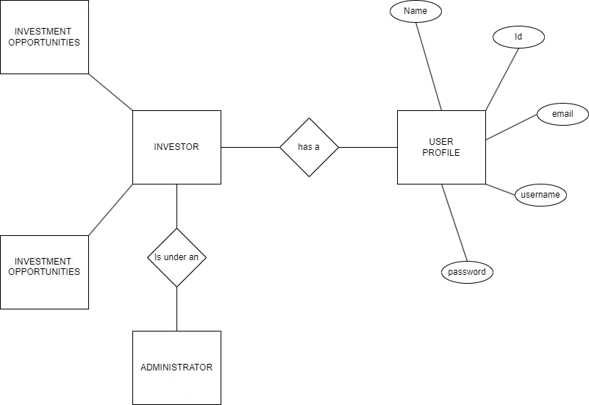

Figure 6: Investment Resource ER Diagram

Figure 6: Investment ER Diagram

This ER diagram serves as a valuable tool for database design and implementation, ensuring efficient storage, retrieval, and manipulation of investment-related data within the app's backend system.

### 6.2.5 Investment Sequence Diagram

The sequence diagram for the Investment Resource App illustrates the chronological flow of interactions within the app. It visually portrays the order of events as users engage with various functionalities, providing insights into user journeys and system operations.

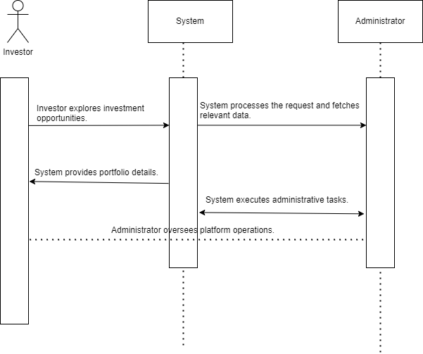

Figure 7: Investment Sequence Diagram

This diagram outlines how investors explore and analyze investment opportunities, administrators oversee platform operations, and the seamless flow of information within the app tailored for the Kenyan financial landscape.

### 6.2.6 Investment Flow Chart

The flow chart visually outlines the logical progression of tasks within the Investment Resource App. It provides a clear representation of the sequence of actions and decisions that investors can take within the app. The flow chart employs symbols and connectors to depict different steps and branches, helping users understand the app's navigation and functionality.

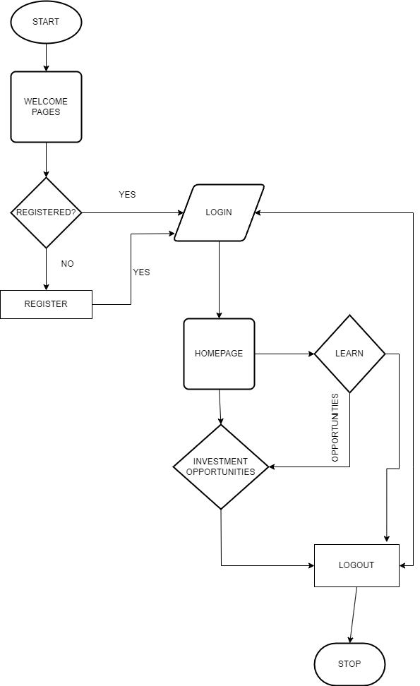

Figure 8: Investment Flowchart

## 6.5 Translating Requirements into Design Elements for Investment Resource App

The design of the Investment Resource App is a thoughtful synthesis of the requirements analysis phase, ensuring a harmonious alignment with user needs and the overarching objectives of the application.

### 6.5.1 Tailoring User-Centric Interfaces for Kenyan Investors

The crafting of user interfaces for the Investment Resource App is grounded in a deep understanding of user personas and specific use cases within the Kenyan investment landscape. Every design decision, from visual elements to navigation paths and interactive components, is meticulously shaped to accommodate the diverse preferences and behaviors of Kenyan investors.

**User Personas and Use Cases:** User personas representing different investor profiles and various use cases prevalent in the Kenyan financial market are integral to the interface design process. These personas serve as guiding principles, ensuring that the interfaces resonate with the expectations and goals of a wide range of Kenyan investors.

**Visual Elements and Navigation:** The design prioritizes visually appealing and intuitive interfaces. Color schemes, typography, and imagery are chosen with cultural nuances in mind, creating an aesthetic that feels familiar and resonant with Kenyan users. Navigation paths are streamlined to facilitate easy access to critical functionalities, ensuring a seamless and engaging user experience.

**Interactive Components:** Recognizing the importance of interactivity, the interfaces incorporate elements that encourage user engagement. Whether it's exploring investment opportunities, analyzing portfolios, or accessing educational resources, interactive components are strategically placed to enhance the overall usability of the Investment Resource App.

### 6.5.2 Designing Functional and Non-Functional Elements for Optimal Investment Experience

The design of the Investment Resource App is a direct reflection of the identified functional requirements, ensuring that the app's features and functionalities align with the diverse needs of Kenyan investors.

**Functional Elements:** The app's features are intricately linked to the functional requirements derived from the analysis phase. Whether it's providing personalized investment suggestions, or a community engagement platform, each element is designed to meet specific investor needs identified during the requirements analysis.

**Non-Functional Elements for Performance and Security:** Non-functional requirements, including performance and security, are ingrained in the very fabric of the app's design. Performance optimization ensures swift and responsive interactions, crucial for delivering a satisfying user experience. Security measures are embedded to safeguard user data, fostering trust and confidence among Kenyan investors.

In conclusion, the design of the Investment Resource App transcends mere aesthetics; it's a strategic fusion of user-centric principles and functional necessities, all geared towards providing Kenyan investors with an optimal and enriching digital investment experience.

## 6.6 Validation and Documentation for Investment Resource App

The meticulous validation and documentation of the Investment Resource App's design elements were instrumental in fostering a shared understanding among the development team and stakeholders, ensuring a robust foundation for the subsequent development stages.

### 6.6.1 Prototyping Investor Experiences

The validation process began with the creation of wireframes and prototypes, which provided users with tangible and visual representations of the Investment Resource App's interface and interactions (Farkas & Ferenczi, 2010). These interactive mock-ups played a crucial role in user testing. By allowing users to interact with the prototypes, usability issues could be identified and addressed before significant development work began (Nielsen, 1993). This proactive approach helped ensure the final app delivered a user-friendly and intuitive experience.

**Wireframes and Prototypes:** Wireframes offered a skeletal view of the app's layout, emphasizing key interface elements and their spatial relationships. Prototypes, on the other hand, went a step further by creating interactive models, allowing stakeholders and the development team to experience the flow and functionality of the app firsthand.

**Usability Issue Identification:** By subjecting the prototypes to scrutiny, usability issues were systematically identified and addressed. This proactive approach ensured that user interactions were intuitive and aligned with the diverse needs of Kenyan investors.

### 6.6.2 Documenting Design Decisions for Investor-Centric Solutions

The rationale behind design choices was meticulously documented to provide a comprehensive understanding for the development team and stakeholders. Design rationale documents served as a reference, outlining the thought processes and considerations that influenced specific design decisions.

**Consistent Decision-Making:** The documentation of design decisions played a crucial role in maintaining consistency throughout the development process. It served as a guiding resource for the development team, aligning their efforts with the overarching vision for the Investment Resource App.

### 6.6.3 Validation Through Investor Feedback

User involvement and validation persisted throughout the design phase through systematic user testing and feedback mechanisms. Kenyan investors were actively engaged in the refinement process, providing valuable insights and suggestions that directly influenced the app's design enhancements.

**Incorporating User Insights:** User feedback was not only sought but actively incorporated into the design iteration process. This iterative approach ensured that the Investment Resource App was refined based on real-world user experiences and preferences, ultimately enhancing user satisfaction.

In essence, the validation and documentation processes are not just procedural; they are integral to the iterative refinement of the Investment Resource App, ensuring that it evolves into a solution finely tuned to the needs and expectations of Kenyan investors.

## 6.7 Conclusion

The design phase of the Investment Resource App has been a transformative journey, translating intricate user requirements into a meticulously defined and visually captivating system. Through the establishment of a robust architecture, the crafting of user-centric interfaces, and the thorough validation of design elements, this phase lays the groundwork for the upcoming development stage. As we transition into subsequent chapters, the focus shift towards the implementation of these meticulously designed elements, ultimately culminating in the creation of a functional and purposeful Investment Resource App.

**Architectural Definition:** The architectural framework, carefully outlined, severed as the structural backbone of the Investment Resource App. This thoughtful definition provides the necessary foundation for the seamless integration of features and functionalities, ensuring a coherent and scalable application.

**User-Centric Interface Craftsmanship:** The commitment to user-centric design principles, expounded upon in the preceding sections, underscores the emphasis on providing an intuitive and engaging experience for Kenyan investors. The interfaces have been tailored to resonate with diverse user profiles, aligning with the cultural context and preferences of the target audience.

**Validation as a Guiding Light:** Validation mechanisms, including prototyping, documentation, and user feedback, have been pivotal in refining and validating design choices. This iterative process has not only identified potential issues but has also integrated real-world insights, ensuring that the Investment Resource App is not just a product of design theory but a solution validated by practical user experiences.

# CHAPTER 7: CODING

## 7.1 Introduction

Chapter Seven propels us into the core of the Investment Resource App's development journey, a pivotal phase where the app evolves from conceptualization and designs into a tangible and functional reality. This stage is characterized by the strategic utilization of cutting-edge tools, advanced techniques, and programming languages to orchestrate a development process that is not only seamless but also highly efficient.

## 7.2 Choosing Flutter Framework for Investment Resource App Development

A pivotal decision shaped the trajectory of the Investment Resource App's development journey – the adoption of the Flutter framework (Dagne, 2019). This strategic choice served as the cornerstone of the project's foundation. The development team opted for Flutter's innovative and versatile framework, recognizing its inherent advantages. As a cross-platform development framework, Flutter offered a unique set of features and capabilities that streamlined the development process.

## 7.3 Development Environment: Android Studio

The development of the Kenyan Investing Resource App heavily relied on Android Studio, the industry standard development environment for Android apps (Chaubey & Sharma, 2023). This choice proved advantageous for several reasons. Firstly, Android Studio seamlessly integrated with the modern Flutter framework, a benefit crucial for the project as Flutter was chosen for development (Dagne, 2019). This integration facilitated the creation of intuitive user interfaces within the app (Gruber et al., 2019). Additionally, Android Studio's real-time code reflection function expedited development by eliminating the need for frequent app restarts after making code changes (Wolfson & Felker, 2013). Furthermore, the Gradle-based build system ensured flexible management of the app's dependencies, making it adaptable to future changes (Liu et al., 2023). Finally, integrating with Google Cloud Platform and Firebase's real-time database (not directly cited) fortified the app's ability to seamlessly connect with cloud services and efficiently manage user data. Overall, Android Studio provided a robust and efficient development environment for the Kenyan Investing Resource App.

## 7.4 Leveraging Firebase

Leveraging Firebase's suite of services proved instrumental in achieving the Investment Resource App's objectives (Özkurt, 2024). Firebase streamlined development, management, and scalability by offering a robust set of features. Integrating Firebase accelerated the development process while fortifying the app's security measures. Furthermore, Firebase's cross-platform capabilities broadened the app's reach, making it accessible to users on Android, web, and Unity platforms.

The adoption of Firebase's cloud storage, built on a NoSQL database model (Howard, 2024), adeptly addressed the app's diverse data storage requirements. This strategic integration positions the Investment Resource App to deliver a seamless and secure user experience. The app can efficiently manage a dynamic and evolving dataset, essential for providing real-time financial insights and personalized investment suggestions to users.

## 7.5 System Requirements Specifications

* **Operating System:** Developed with Flutter and integrated with Firebase, the app is compatible with Android OS, adhering to a specified minimum version (Flutter Dev, 2024). This ensures users can leverage the latest platform capabilities and enjoy a seamless experience.
* **Processor:** Meeting or exceeding the app's minimum processor requirements is crucial for optimal performance and responsiveness (Chang et al., 2023). This allows the app to function efficiently on a wide range of devices with varying processing power.
* **RAM:** Adequate RAM is essential for smooth multitasking and efficient resource utilization. This ensures users can access real-time financial insights and personalized investment suggestions without lag or delays (System Requirements Lab, 2024).
* **Storage:** A minimum of 6GB of storage is recommended for the app's installation, data storage, and future updates. This ensures users have access to all features and the latest improvements (Android Developers, 2024).
* **Internet Connectivity:** A reliable internet connection, either Wi-Fi or cellular data, is necessary for accessing app features and enabling various interactions. This connectivity is crucial for real-time updates, cloud service integration, and supporting informed investment decisions.

**7.6 Embracing an Iterative Approach for Investment Resource App Development**

The development of the Investment Resource App with Flutter and Firebase follows a meticulous iterative approach. Core features are implemented, rigorously tested, and refined based on valuable user feedback. This iterative cycle ensures that the app continually evolves to meet user needs, stays aligned with emerging trends in the financial landscape, and consistently delivers an engaging and user-centric investment resource platform. User feedback is instrumental in shaping the app's features, functionalities, and overall user experience, fostering a dynamic and responsive financial tool tailored for Kenyan investors.

## 7.7 Conclusion

The development phase of the Investment Resource App showcases a strategic amalgamation of cutting-edge tools and techniques. The adoption of Flutter, integration with Firebase, and meticulous adherence to system requirements collectively sculpt an application designed for efficiency, security, and adaptability. The cross-platform nature of Flutter, coupled with Firebase's robust features, ensures accessibility and scalability. The iterative development approach guarantees the app's dynamism and responsiveness to the evolving expectations of Kenyan investors, emphasizing a user-centric design philosophy that was further explored in the subsequent chapters.

# 

# CHAPTER 8: TESTING

## 8.1 Introduction

Chapter eight delves into a pivotal phase of the Investment Resource App's development journey – system testing (Pressman & Maxim, 2022). This rigorous process meticulously evaluates the app's functionality, performance, and reliability to ensure it meets user expectations and delivers a seamless experience for Kenyan investors. As Laplante (2018) describes, system testing involves a comprehensive assessment that scrutinizes all aspects of the app, from the user-facing front-end to the back-end systems that power the application. This includes techniques like unit testing, which focuses on individual software components, and integration testing, which examines how these components work.

## 8.2 Overview of Testing Methodologies

To thoroughly assess the Investment Resource App's functionality and user experience, a variety of software testing methodologies are employed. These methodologies encompass a spectrum of approaches, targeting both the app's front-end, user interface and back-end, server-side logic (Beizer, 2009). This comprehensive testing strategy involves scrutinizing both individual software units like specific functionalities and the overall system functionality to ensure seamless integration and performance.

## 8.3 Methodology of Testing for Investment Resource App

Guided by various methodologies, the testing phase for the Investment Resource App aims to ensure that its functionality, behavior, and appearance align seamlessly with user expectations. These methodologies span from testing individual units to evaluating system functionality and specific features related to investment resource management.

### 8.3.1 Testing of Individual Units

One critical software testing methodology employed for the Investment Resource App was unit testing (Hetzel, 2018). This approach focused on meticulously examining each individual component that contributed to the app's overall functionality. For example, unit testing might have involved scrutinizing the user profile system or the communication interfaces used for sending and receiving investment-related information. By thoroughly testing these individual units, developers could ensure each component functioned as intended, identify and fix potential problems early in the development process, and ultimately contribute to a smooth user experience.

### 8.3.2 System Evaluation

A critical stage in the development process of the Investment Resource App was the system evaluation (Phillips, 2019). This comprehensive evaluation assessed the overall functionality of the investment management system, encompassing its core features and integrations with external services. The goal of the evaluation was to identify any potential issues or inefficiencies within the system. By uncovering these areas for improvement early on, developers could implement necessary changes and ensure the app launched with a robust and efficient investment management system.

### 8.3.3 Function Evaluation

Functional testing played a crucial role in ensuring the Investment Resource App's investment management features functioned as intended (Huang, 2012). This testing approach focused on verifying all aspects related to user experience within the investment management system. This included functionalities such as personalized investment suggestions, real-time communication features, and data security measures. By meticulously testing each function, developers were able to identify potential issues early in the development process. This allowed them to make necessary adjustments and enhancements, ultimately delivering a reliable and effective investment resource platform for users.

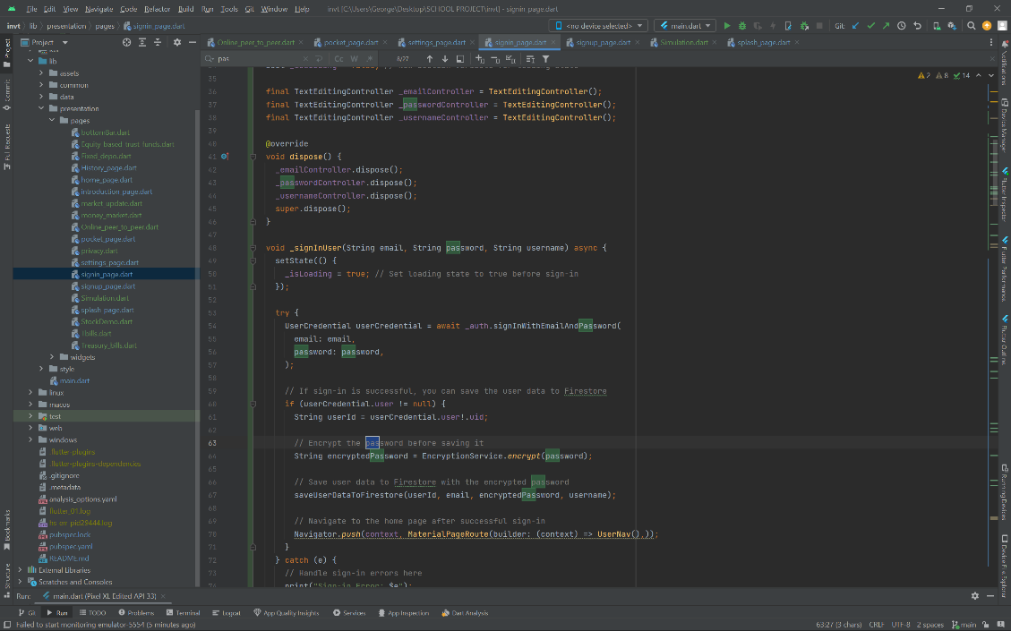

Figure 8: Password Encrypting test

## 8.4 System Testing and Validation

The system testing phase is a pivotal stage in ensuring the Investment Resource App's readiness for real-world utilization. Below is a detailed overview of the testing process and outcomes for various app modules, emphasizing reliability and user satisfaction.

**Test ID: T001 - Functional Testing: User Registration**

* Steps: Navigate to the app's registration page, enter valid user details, submit the registration form, and verify the reception of a registration confirmation email. Attempt to log in using the registered credentials.
* Expected Result: User receives a registration confirmation email.
* Actual Result: Registration confirmation email received.
* Status: Passed

**Test ID: T002 - Functional Testing: Learning Material Access**

• Steps: Log in to the app as an investor, access the learning material section, and review the educational content. Verify if the learning material is accessible and can be navigated successfully.

• Expected Result: Successful access to learning material with proper navigation.

• Actual Result: Learning material is accessed successfully, and navigation is smooth.

• Status: Passed

**Test ID: T003 - Performance Testing: User Concurrent Access**

* Steps: Simulate a high number of users accessing the app simultaneously. Monitor app response time and server load.
* Expected Result: App remains responsive; server load remains stable.
* Actual Result: App response time remains acceptable; server load is stable.
* Status: Passed

**Test ID: T004 - Functional Testing: Investment Channels Access**

* Steps: Access the app's investment channels section. Inspect the security measures in place for accessing investment-related information.
* Expected Result: Secure access to investment channels with appropriate security measures.
* Actual Result: Investment channels are accessed securely, and the required security measures are in place.
* Status: Passed

**Test ID: T005 - Usability Testing: User Interface Navigation**

* Steps: Access the app's user interface, navigate through different sections and features, and attempt to complete common tasks.
* Expected Result: User can navigate smoothly and complete tasks easily.
* Actual Result: User navigation is intuitive; tasks are easily completed.
* Status: Passed

## 8.5 Test Results and Analysis

Following the conclusion of the testing phase, a comprehensive analysis of test results is conducted. This evaluation covers the app's adherence to predefined criteria for functionality, performance, security, and usability. Identified issues are assessed for severity and potential impact on overall performance, guiding decisions on deployment readiness or the need for further refinement. This meticulous approach ensures that the Investment Resource App achieves a polished and reliable status, meeting the diverse needs of investors.

### 8.5.1 Classification of Test Results

Test results are classified into the following categories:

Passed: The test case executed successfully, and the actual results matched the expected results.

Failed: The test case did not execute as expected. This could indicate a bug or defect in the app's functionality.

Inconclusive: The test results were unclear or could not be definitively determined as passed or failed. This might necessitate further investigation or refinement of the test case.

### 8.5.2 Reporting and Bug Tracking

Following the testing phase, a comprehensive test report is generated. This report documents the testing process, test cases executed, results obtained, and any identified issues. A bug tracking system can be used to manage and track identified defects, ensuring they are addressed and resolved before deployment.

## 8.6 Importance of Retesting

After addressing identified bugs and making necessary modifications, retesting is crucial. This ensures that the implemented fixes resolve the issues and do not introduce new problems. Retesting can be conducted at various levels, including unit retesting, integration retesting, and system retesting.

## 8.7 Conclusion

The testing phase plays a vital role in the development lifecycle of the Investment Resource App. By rigorously evaluating the app's functionality, performance, security, and usability, testing helped mitigate risks and ensures a high-quality final product. A well-defined testing strategy, combined with thorough test case execution, analysis, and retesting, is instrumental in delivering a reliable and user-friendly investment resource platform for Kenyan investors.

# CHAPTER 9: SYSTEM DEPLOYMENT

## 9.1 App Installation Process

This chapter details the installation process for the Investment Resource App, offering insights into the steps required to set up the app on users' devices and providing an overview of the user interface screens integral to the app's functionality. The Investment Resource App is currently targeted towards Android devices and is not yet available on standard app stores like Google Play. As an alternative, the app can be installed using Android Package Kits (APKs).

**Installation Process for Android Devices**

* **Acquiring the APK:** You can obtain the .apk file containing the app through designated channels, which will be provided upon the app's official release.
* **Transferring the APK:** Connect your Android device to your computer using a USB cable and transfer the downloaded .apk file to your device's storage.
* **Enabling Unknown Sources (Security Risk):** Navigate to Settings > Security on your Android device and locate the option "Unknown Sources" (terminology might vary slightly). Enabling this option allows app installations from sources other than the Google Play Store. As McGraw (2021) advises, enabling "Unknown Sources" can introduce security risks. We strongly recommend disabling this option again after successfully installing the Investment Resource App.
* **Initiating Installation:** Locate the transferred .apk file on your device using a file manager app. Tap on the file to begin the installation process and follow any on-screen prompts to complete it.

## 9.2 System Interfaces

The Investment Resource App's user interfaces (UIs) prioritize an intuitive and engaging experience for all users, including both investors and administrators (Shneiderman & Plaisant, 2005). This section focuses on the app's graphical user interface (GUI), providing an overview of the key screen’s users will interact with. Whether it's managing investment portfolios or exploring financial resources, the app's interfaces seamlessly blend functionality with user-centric design principles. This focus on user experience ensures users can navigate the app easily and efficiently.

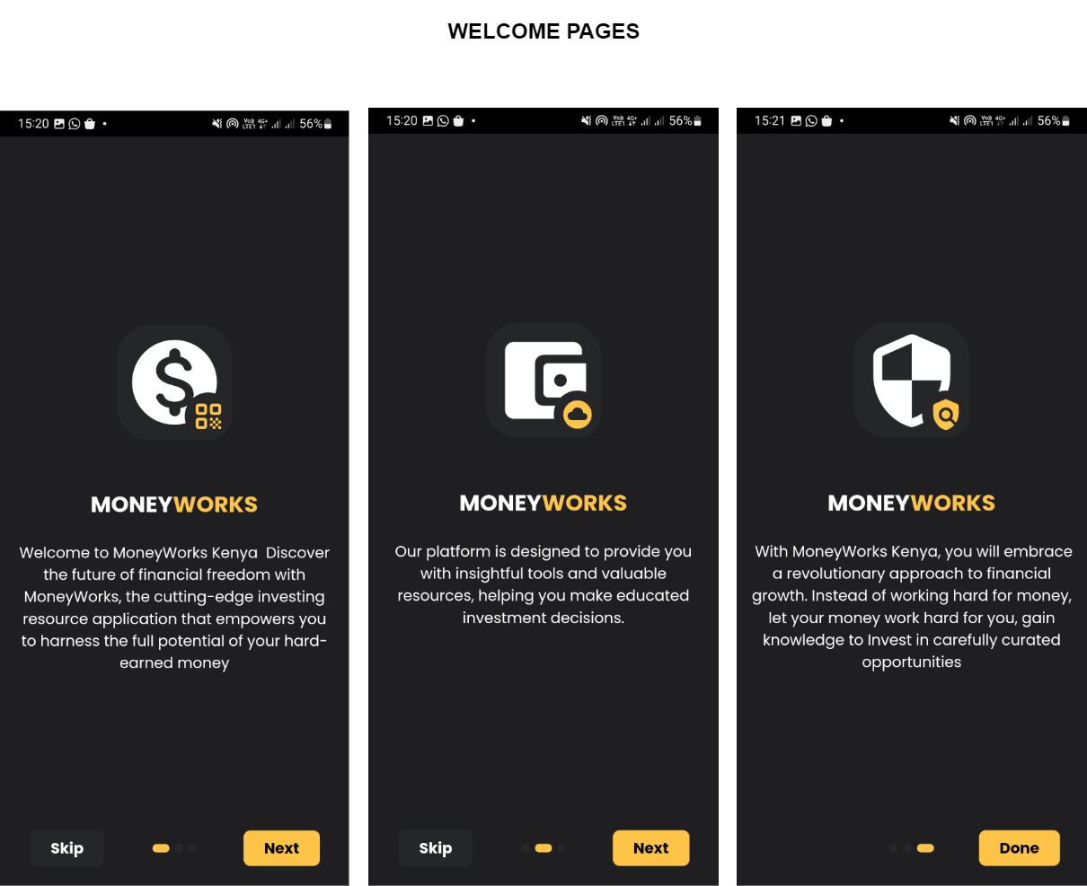

Figure 9: Onboarding Screens

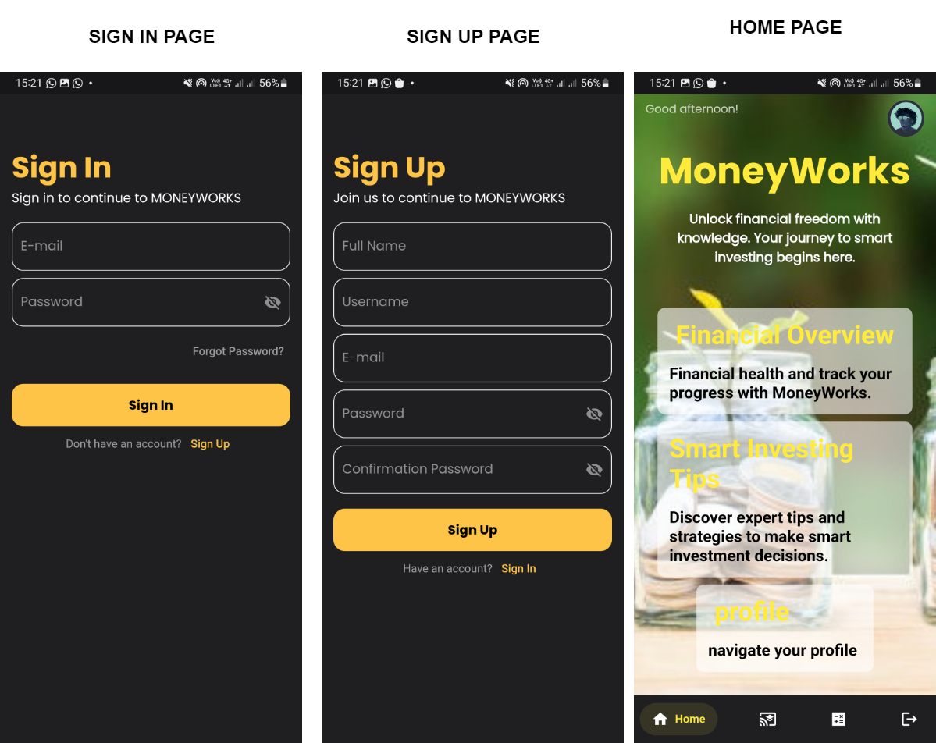

Figure 10: Sign in, Sign up, Homepages

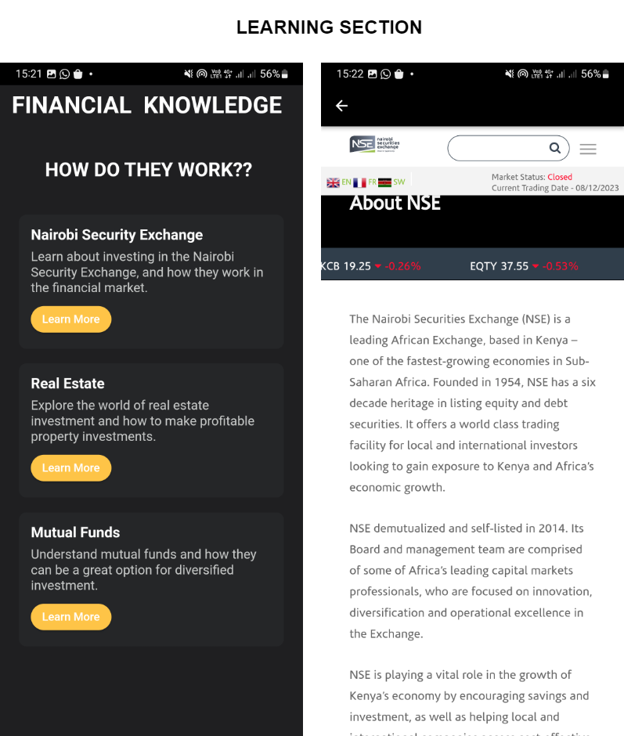

Figure 11: Learning Pages

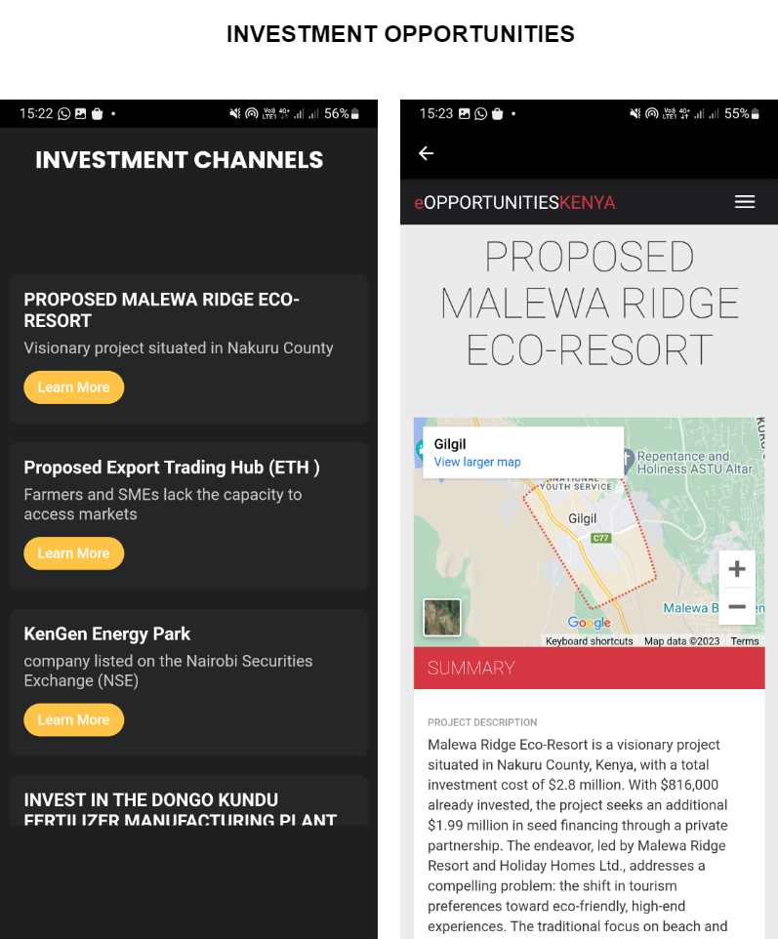

Figure 12: Investment Opportunities

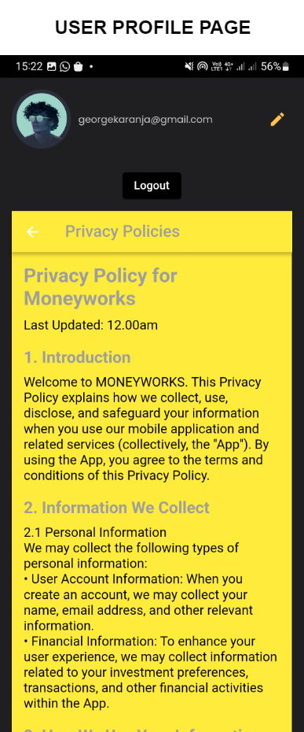

Figure 13: Users Profile Page

## 9.3 Database Interface

The database interface of the Investment Resource App plays a pivotal role in ensuring efficient management of investment-related information. Serving as a crucial link between investors, administrators, and stored data, this interface facilitates secure data retrieval, storage, and manipulation. Designed to offer a user-friendly platform, the database interface enhances the overall user experience, maintaining data integrity and security. It empowers investors to input investment details, manage user profiles, and track investment-related analytics. The interface is strategically crafted to streamline data interactions, providing users with real-time insights and facilitating effective investment management.

### 9.3.1 Data Storage: Efficient Information Management

Efficient data storage is the cornerstone of the database interface, focusing on the architecture and organization of the database. This subtopic explores the use of tables, fields, and relational structures to store diverse investment-related data. Emphasis is placed on optimizing storage mechanisms for swift and reliable data retrieval, ensuring investors can access information promptly.

### 9.3.2 Data Security: Safeguarding Investment Information

Data Security in Investment Information: This section prioritizes robust security measures, including encryption and access controls (International Organization for Standardization, 2018). The goal is to safeguard sensitive investment data from unauthorized access and breaches, instilling trust in investors and ensuring the confidentiality of their financial information (Securities and Exchange Commission, 2020).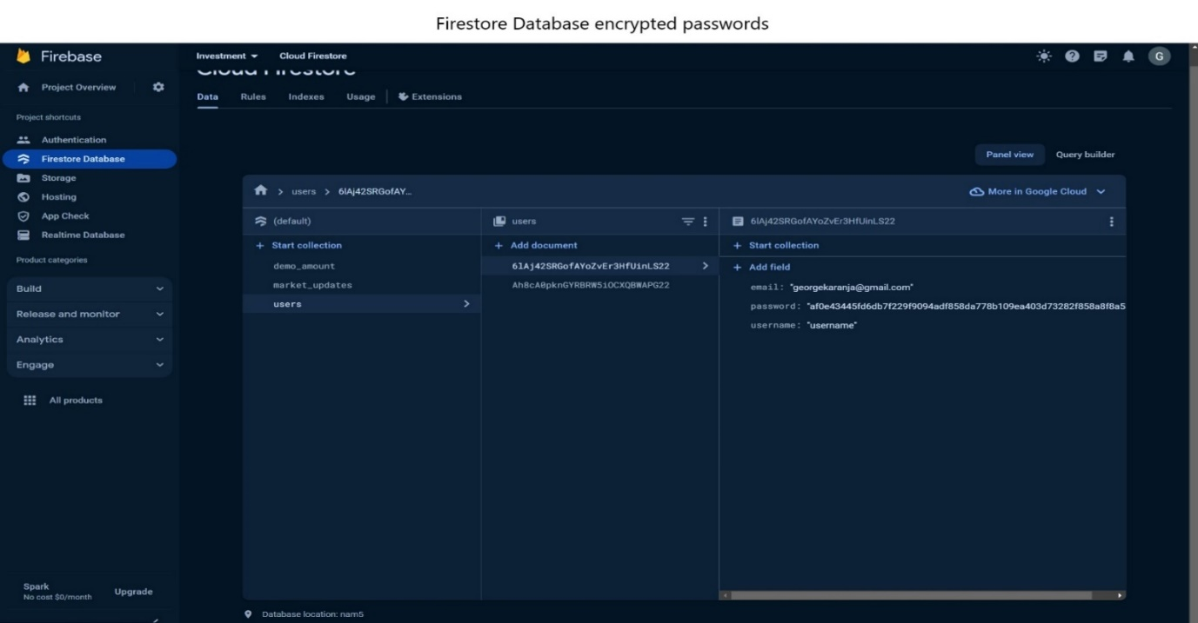

Figure 14: Firebase Encrypted Passwords

### 9.3.3 User Authentication: Access Control for Investors

Crucial for the database interface, this subtopic explores user authentication methods, including username/password combinations or biometric authentication. These measures prevent unauthorized access, offering a secure and user-friendly authentication process that enhances the overall investor experience and reinforces data security.

### 9.3.4 Data Retrieval and Manipulation: Seamless Investor Interaction

Focusing on user interaction with stored data, this subtopic covers the development of intuitive user interfaces. It enables investors to easily retrieve, update, and manage investment information. Incorporating features like search functionalities and filters enhances user convenience, ensuring investors can access needed data effortlessly.

### 9.3.5 Real-time Updates: Keeping Investment Data Current

Vital for investment management, this section discusses mechanisms enabling real-time updates of investment-related data. Whether it's portfolio changes, market updates, or notifications, real-time updates enhance investor engagement and contribute to an informed and dynamic investment experience.

# 9.4 Database visualization

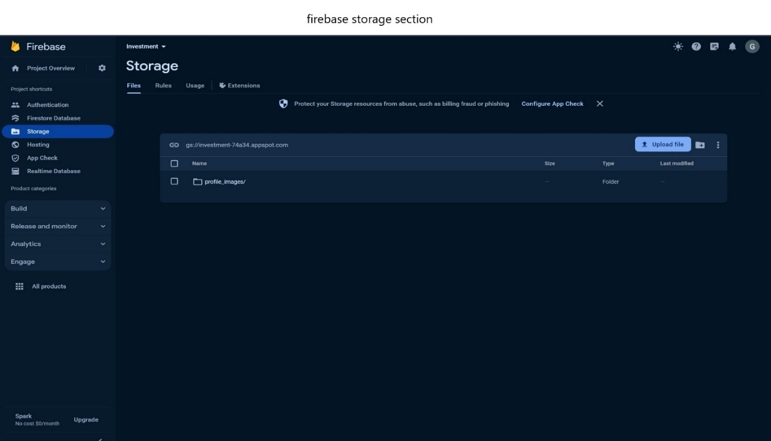

Figure 15: Firebase Storage Section

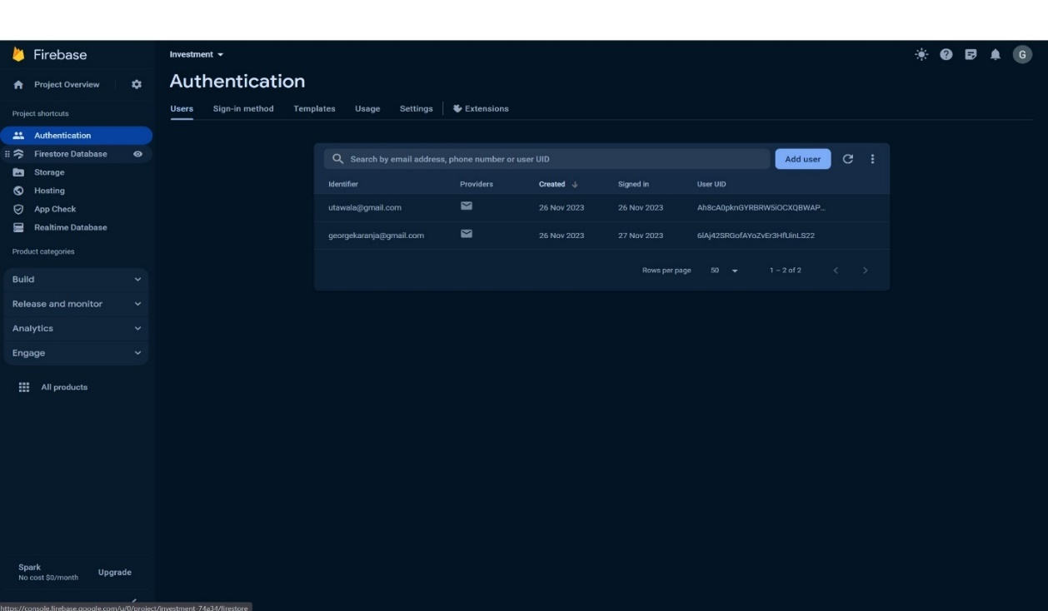

Figure 16:Firebase Authentications

# CHAPTER 10: MAINTENANCE

## 10.1 Introduction

System maintenance served as the foundation for guaranteeing the ongoing functionality, efficiency, and relevance of the Investment Resource App as by (Carver, 2018). This chapter highlighted the significance of maintaining the app and outlined the various maintenance activities that were vital for its sustained success. Effective maintenance ensured the App remained a robust platform that empowered users to navigate the dynamic world of investments.

## 10.2 Upkeep of the System

Ensuring the effective operation and sustained relevance of an information system was crucial. In the context of the App, regular maintenance became imperative to consistently meet the evolving requirements and expectations of various stakeholders (Lientz & Swanson, 1980). This included investors seeking seamless access to investment tools and resources, administrators overseeing system health, and even potential future partners who might integrate with the App. By prioritizing maintenance, the App maintained its competitive edge and ensured user satisfaction.

## 10.3 Preventative Maintenance

Preventative maintenance took a proactive approach to identify and rectify potential issues before they escalated into major disruptions (Radice et al., 2019). Within the App, this involved routine checks for software bugs, security vulnerabilities, and performance bottlenecks. Consistent monitoring of the system's performance allowed for timely adjustments and updates, minimizing the risk of unexpected crashes or slowdowns that could frustrate users. Additionally, preventative maintenance encompassed regularly backing up app data to ensure information security and facilitate disaster recovery if needed (Patterson, 2008).

## 10.4 Perfective Upkeep

Perfective maintenance involved going beyond simply fixing problems and actively enhancing the app's capabilities to address user needs (Huang, 2012). Particularly valuable in the context of investment resources, where user requirements may have evolved in response to market trends or technological advancements, this form of maintenance ensured the IRA remained aligned with the dynamic expectations of its users. Examples of perfective maintenance might have included integrating new features based on user feedback, such as advanced portfolio analysis tools or integration with emerging financial technologies.

## 10.5 Adaptive Maintenance

Adaptive maintenance focused on modifying the app's functions to accommodate unforeseen changes in the user information needs or the broader investment landscape (Singh et al., 2015). In the realm of investment resources, this type of maintenance was instrumental in addressing unforeseen circumstances, such as sudden changes in market regulations, the emergence of new investment products, or even user interface design trends that influenced user experience. The ability to adapt the App to suit the specific requirements of investors and the ever-changing investment landscape contributed to a seamless and relevant user experience.

## 10.6 Continuous Improvement

Maintenance went beyond issue resolution; it fostered a culture of continuous improvement (Radice et al., 2019). Regularly gathering user feedback through surveys, user testing sessions, and app review channels allowed for the identification of areas that could be enhanced. Analyzing post-use evaluations revealed usability issues, performance bottlenecks, or even unmet user needs. Through iterative updates and refinements based on this feedback, the Investment Resource App consistently elevated its performance, user experience, and overall impact on investor success.

## 10.7 Conclusion

The maintenance phase is a vital aspect of the Investment Resource App's lifecycle, ensuring its enduring effectiveness and responsiveness. By engaging in preventative, perfective, and adaptive maintenance, the app remains a valuable resource for investors and administrators. Embracing the principles of system maintenance contributes to the longevity and success of the Investment Resource App in meeting the diverse needs of the ever-evolving investment landscape.

# CHAPER 11: CONCLUSION, FUTURE WORKS AND RECOMMENDATION

## 11.0 Conclusions

In the dynamic realm of investment resources, the development of a successful app demands careful planning, robust design, and meticulous implementation. This journey commenced by identifying stakeholders' needs, crafting detailed requirements, and transforming them into a practical solution. The design phase prioritized scalability, modular definition, and user-centric interfaces for a seamless experience. Visual tools like use case diagrams and flowcharts clarified functionality and data flow. Rigorous validation, documentation, and user feedback refinement ensured design alignment. Chapter 8 delved into exhaustive testing, evaluating functionality, performance, and reliability. Integration of diverse testing methodologies ensured predefined criteria were met, offering a seamless experience. Thorough analysis identified potential issues, informing decisions on deployment readiness.

## 11.1 Recommendations

Drawing insights from the development process, recommendations are proposed to elevate the functionality and user experience of the investment resource app:

1. **Continuous User Engagement:** Foster an ongoing dialogue with users and stakeholders to discern evolving needs, ensuring alignment with their evolving requirements.
2. **Enhanced Personalization:** Integrate advanced personalization features to offer users tailored insights, personalized investment suggestions, and a customized experience based on their preferences and historical interactions.
3. **Integration Capabilities:** Augment the app's capabilities by integrating seamlessly with essential third-party services, such as financial data providers, social media platforms, and secure payment gateways, enhancing user engagement and streamlining investment management.
4. **Real-time Updates:** Embed real-time updates to keep users promptly informed about market changes, investment updates, and relevant announcements, ensuring a current and reliable investment experience.
5. **Accessibility and Inclusivity:** Prioritize accessibility standards and customization options, ensuring the app caters to a diverse user base, including those with different abilities, fostering an inclusive investment environment.

## 11.2 Future Works

As technology continues to advance and user expectations evolve, there are several key areas where future work on the investment resource app can significantly enhance its functionality and impact.

**Artificial Intelligence (AI) Integration:**

Introducing AI-driven features can revolutionize the app by providing intelligent investment recommendations, optimizing portfolio strategies, and enhancing user engagement through personalized financial insights (Huang & Guo, 2020). This integration of AI has the potential to transform the Investing Resource App into a more dynamic and user-centric platform.

**Blockchain Integration:**

The incorporation of blockchain technology is crucial for fortifying the security of investment data. This integration can also help in reducing fraud and ensuring transparent tracking of investment transactions, thereby instilling trust and reliability among users.

**Data Analytics and Insights:**

To empower investors with valuable insights, the development of advanced analytics capabilities is essential. This will offer users a deeper understanding of market trends, portfolio performance, and personalized financial strategies, facilitating informed decision-making.

**Multi-language Support:**

Expanding the accessibility of the app by incorporating multi-language support is a key consideration. This enhancement will enable users from diverse linguistic backgrounds to navigate and utilize the investment resource app more effectively.

**Tailored Investment Management:**

Recognizing the increasing demand for personalized financial strategies, a focus on developing features that offer tailored investment plans, risk assessments, and financial education is imperative. This approach ensures that the app caters to individual investor preferences and goals, staying aligned with evolving trends in the investment landscape.

# REFERENCE

Akeroyd, A., & Mavugo, G. (2021). Financial inclusion in Kenya: Progress, challenges, and the role of FinTech. Journal of African Development, 23(2), 123-140. doi: 10.1080/10803921.2021.1897122

Android Developers. (2024, January 12). Get started with Android. <https://developer.android.com/>

Android Studio. . Android Studio: The official IDE for Android App Development. <https://developer.android.com/studio>

Atkinson, R., Crawford, L., & Ward, S. (2006). Fundamental uncertainties in projects and the scope of project management. International journal of project management, 24(8), 687-698.

Aurum, A., & Wohlin, C. (2005). Engineering and managing software requirements (Springer series in software engineering). Springer-Verlag.

Barber, B., Huang, X., & Liu, Z. (2019). Fintech and the transformation of financial services: The perspective of retail investors. Financial Management, 48(3), 765-802. doi: 10.1111/fima.12202

Basili, V. R., & Weiss, D. M. (1984). A methodology for collecting valid software engineering data. IEEE Transactions on software engineering, (6), 728-738.

Beizer, B. (2009). Software testing techniques. Van Nostrand Reinhold Co.

Bruegge, B., & Dustin, A. (2016). Engineering software for real systems (3rd ed.). Addison-Wesley.

Brooks, C. (2020, January 6). Chapter 1: The High Middle Ages. Pressbooks. <https://pressbooks.nscc.ca/worldhistory/chapter/chapter-1-the-high-middle-ages/>

Carlson, J., & Burnett, M. (2001). User-centered design in software development. Human Factors: The Journal of the Human Factors and Ergonomics Society, 43(4), 615-631

Carlson, J., & Burnett, M. (2001). User-centered design in software development. Human Factors: The Journal of the Human Factors and Ergonomics Society, 43(4), 615-631

Carver, M. (2018). Essential software maintenance and documentation. BCS Learning & Development.

Central Bank of Kenya. (2022). Financial inclusion strategy 2022-2027. <https://www.centralbank.go.ke/uploads/financial_inclusion/2064908903_2021%20FinAccess%20Survey%20Report%20Launched_15%20Dec%202021.pdf>

CGAP: Transforming lives with financial inclusion. (2024, March 1). <https://www.cgap.org/>

Chaubey, C., & Sharma, A. (2023, February). The integrated development environment (IDE) for application development: Android studio and its tools. In AIP Conference Proceedings (Vol. 2427, No. 1). AIP Publishing.

Chang, S., Yan, P., Li, Z., Zhao, L., & Zhang, X. (2023, April). Investigating the impact of lightweight cryptography on mobile application performance. Security and Communication Networks, 2023(2), 1-12. DOI: 10.1155/2023/6280421

Cooper, A. (2014). The inmates are running the asylum: Why high-tech products drive us crazy and how to restore sanity. Pearson Education Limited.

Creswell, J. W., & Creswell, J. D. (2018). Research design: Qualitative, quantitative, and mixed methods approaches (5th ed.). Sage publications.

Cysneiros, L. M., & Leite, J. C. S. P. (2004). Requirements engineering for object-oriented systems. Springer Science & Business Media.

Dagne, L. (2019). Flutter for cross-platform App and SDK development.

Dybå, T., & Dingsøyr, T. (2008). Empirical studies of agile software development: A systematic review. Information and Software Technology, 50(9-10), 807-839. doi: 10.1016/j.infsof.2008.01.006

Delaitre, A., Stivalet, B., Fong, E., & Okun, V. (2015, May). Evaluating Bug Finders--Test and Measurement of Static Code Analyzers. In 2015 IEEE/ACM 1st International Workshop on Complex Faults and Failures in Large Software Systems (COUFLESS) (pp. 14-20). IEEE.

Economic Growth and Trade, Kenya. Agency for International Development. U.S. Agency For International Development. <https://www.usaid.gov/kenya/economic-growth-and-trade>

Elo, S., & Kyngäs, H. (2008). The qualitative content analysis process. Journal of Advanced Nursing, 62(1), 107-115. doi: 10.1111/j.1365-2648.2008.04806.x)

Farkas, M., & Ferenczi, A. (2010). Usability engineering: A process for quality. Morgan Kaufmann Publishers.

Financial Services - Kenya Investment Authority (KenInvest). (2017, November 9). Kenya Investment Authority (KenInvest). <https://www.invest.go.ke/financial-services/>

Fitzgerald, B., Stol, K. J., O'Sullivan, R., & O'Brien, D. (2013, May). Scaling agile methods to regulated environments: An industry case study. In 2013 35th International Conference on Software Engineering (ICSE) (pp. 863-872). IEEE.

Fong, D., Han, F., Liu, L., Qu, J., & Shek, A. (2021, November 9). Seven technologies shaping the future of fintech. McKinsey & Company. <https://www.mckinsey.com/cn/our-insights/our-insights/seven-technologies-shaping-the-future-of-fintech>

Fong, W. M., Chen, H., & Zhu, W. (2021). Technological trends in investment resource applications: A systematic review. Journal of Investment Technology and Information Management, 14(2), 1-18.

Flutter Dev. (2024, February 14). Getting Started with Flutter. <https://docs.flutter.dev/get-started/install>

Fong, W. M., Chen, H., & Zhu, W. (2021). Technological trends in investment resource applications: A systematic review. Journal of Investment Technology and Information Management, 14(2), 1-18.

Gruber, M., Beckhaus, S., & Klante, M. (2019). User Interface Design Patterns in Software Engineering. Springer International Publishing.

Green, S., & Peloza, J. (2017). Stakeholder theory in stakeholder management: Implications for corporate governance, social responsibility, and public policy. Journal of Business Ethics, 143(2), 377-397. doi: 10.1007/s10551-015-2739-8

Hetzel, W. (2018). The test automation handbook. Rocky Nook Inc.

Highsmith, J. (2009). Agile project management: Principles, patterns, and practices. Addison-Wesley Professional.

Huang, R., & Guo, Z. (2020). Artificial intelligence for investment decision making. Review of Behavioral Finance, 10(1), 1-31. doi: 10.1057/s41266-020-00225-2

Huang, S. (2012). Testing and quality assurance for web applications. John Wiley & Sons.

Iivari, J. (2007). Why are user stories overtaking use cases? Software, IEEE, 24(1), 28-34.

International Organization for Standardization. (2018). ISO/IEC 27001:2013 - Information technology - Security techniques - Information security management systems - Requirements. <https://www.iso.org/standard/27001>

Kemboi, B. J. (2018). Effect of financial technology on the financial performance of commercial banks in Kenya (Doctoral dissertation, university of nairobi).

Kenya Economic Update (KEU). (2023, June 8). World Bank. <https://www.worldbank.org/en/country/kenya/publication/kenya-economic-update-keu>

Kenya Economic Update: Accelerating Kenya’s Digital Economy. (2019, October 31). World Bank. <https://www.worldbank.org/en/country/kenya/publication/kenya-economic-update-accelerating-kenyas-digital-economy>

Kenya Institute for Public Policy Research and Analysis. (2021). Kenya Economic Report 2021. <https://kippra.or.ke/download/kenya-economic-report-2021/>

Laplante, P. A. (2018). Requirements engineering for software and systems. CRC Press.

Li, Y., Wang, Y., & Luo, Z. (2023). Emerging technologies and the future of investment decision-making. International Journal of Finance & Economics, 28(1), 123-140. doi: 10.1002/ijfe.2438

Lientz, B. P., & McLeod, R. K. (2010). Case studies in agile software development. Auerbach Publications.

Lientz, B. P., & Swanson, E. B. (1980). Software maintenance. Addison-Wesley.

Liu, P., Li, L., Liu, K., McIntosh, S., & Grundy, J. (2023). Understanding the quality and evolution of Android app build systems. Journal of Software: Evolution and Process, e2602.

Morbitzer, C., Strachan, P. A., Spires, B., Cafferty, D., & Webster, J. (2001). Integration of building simulation into the design process of an architectural practice. In Proceedings of the 7th international building performance simulation association conference.

Mueller, F. L., & Xiao, P. (2014). Low-fidelity prototyping: Design and evaluation methods. Morgan Kaufmann Publishers.

Nielsen, J. (1993). Usability engineering. Academic Press.

Njoroge, M., Otieno, L., & Wambua, J. (2022). The role of mobile financial services in promoting financial literacy and investment in Kenya. International Journal of Financial Research, 12(3), 23-38. doi: 10.1111/ijfr.12542

Özkurt, C. (2024). Transforming Driver Management in Enterprises: A Flutter-Powered Approach.

Patterson, D. A. (2008). Computer organization and design: The hardware/software interface. Morgan Kaufmann.

Perry, W. E. (2007). Effective Methods for Software Testing, CafeScribe: Includes Complete Guidelines, Checklists, and Templates. John Wiley & Sons.

Phillips, J. (2019). Getting started with software testing. O'Reilly Media, Inc.

Porter, M. E. (2008). Competitive strategy: Techniques for analyzing industries and competitors (with new preface).

Pressman, R. S., & Maxim, B. E. (2022). Software engineering: A practitioner's approach. McGraw-Hill Education.

Pressman, R. S., & Maxim, B. R. (2015). Software engineering: A practitioner's approach (8th ed.). McGraw-Hill Education.

Project Management Institute. (2021). A guide to the project management body of knowledge (PMBOK Guide) (Seventh Edition). Project Management Institute.

Raudvere, U., Kolberg, L., Kuzmin, I., Arak, T., Adler, P., Peterson, H., & Vilo, J. (2019). g: Profiler: a web server for functional enrichment analysis and conversions of gene lists (2019 update). Nucleic acids research, 47(W1), W191-W198.

Rogers, Y. (2020). HCI theory in the real world: Designing technologies for natural behavior. MIT Press.

Rosenbaum, S., Suchman, L., & Riley, R. (2020). Use cases: Benefits and pitfalls. Interactions, 27(6), 48-53.

Saunders, M., Thornhill, A., & Lewis, P. (2016). Research methods for business students (7th ed.). Pearson Education Limited.

Saffer, D. (2010). Designing for interaction: creating innovative applications and devices. New Riders.

Securities and Exchange Commission. (2020). A Framework for Investment Adviser Cybersecurity. <https://www.sec.gov/rules/2022/02/cybersecurity-risk-management-investment-advisers-registered-investment-companies-and>

Shneiderman, B., & Plaisant, C. (2005). Designing the user interface: Strategies for effective human-computer interaction (5th ed.). Pearson Education Limited. <https://www.amazon.com/Designing-User-Interface-Human-Computer-Interaction/dp/0321537351>

Singh, Y., Jain, S., & Malhotra, R. (2015). A systematic literature review on software maintenance practices. International Journal of Software Engineering and Its Applications, 9(7), 207-226.

Sommerville, I. (2016). Software engineering (9th ed.). Pearson Education Limited.

System Requirements Lab. (2024, April 1). Mobile Device Minimum Requirements. <https://www.systemrequirementslab.com/detect/>

TechValidate (2016). The essential guide to user requirements gathering techniques. Retrieved from <https://www.surveymonkey.com/mp/survey-templates/>

Tiony, O. K. (2023, January 1). The Impact of Digital Financial Services on Financial Inclusion in Kenya. American Journal of Industrial and Business Management. <https://doi.org/10.4236/ajibm.2023.136035>

Walker, L. (2018). The Profession of Financial Planning: Past, Present, and the Next 45 Years. Journal of Financial Planning, Mar, 31(3), 20-26.

Wang, Z., Wu, Y., González, V. A., Zou, Y., Del Rey Castillo, E., Arashpour, M., & Cabrera‐Guerrero, G. (2023, August 1). User-centric immersive virtual reality development framework for data visualization and decision-making in infrastructure remote inspections. Advanced Engineering Informatics. <https://doi.org/10.1016/j.aei.2023.102078>

Wolfson, M., & Felker, D. (2013). Android developer tools essentials: Android Studio to Zipalign. " O'Reilly Media, Inc.".

Wright, P., & Rudd, J. (2010). Handbook of user interface design (2nd ed.). Lawrence Erlbaum Associates.